### 

### **A CRM APPLICATION FOR WHOLESALE**

### **RICE MILL**

**By**

**Ishika Goyal**

**gishika373@gmail.com**

**Project Abstract**

The "CRM Application for Wholesale Rice Mill" is a specialized customer relationship management system designed to streamline and enhance the operational efficiency of rice mills. This application focuses on the unique needs of wholesale rice distributors, providing a platform to manage customer interactions, sales processes, and inventory control effectively. The system integrates features like customer data management, order tracking, billing, and real-time inventory updates, enabling wholesalers to respond promptly to market demands and customer inquiries. The application also includes analytical tools for forecasting sales trends, optimizing supply chains, and improving customer satisfaction. By automating routine tasks and providing actionable insights, the CRM application aims to boost productivity, reduce operational costs, and foster stronger relationships with customers.

**INDEX Page**

**Topics Page no**

Introduction - - - - - - - - - - - - - - - - - - - - - - - - 04

Creating Account - - - - - - - - - - - - - - - - - - - - - - - - 05

Creating Objects - - - - - - - - - - - - - - - - - - - - - - - - 06

Creating Tabs - - - - - - - - - - - - - - - - - - - - - - - - 10

Creating a Lightning app - - - - - - - - - - - - - - - - - - - - - - - - 14

Creating Fields - - - - - - - - - - - - - - - - - - - - - - - - 16

Creating a Page layout - - - - - - - - - - - - - - - - - - - - - - - - 29

Creating Profiles - - - - - - - - - - - - - - - - - - - - - - - - 32

Creating Roles - - - - - - - - - - - - - - - - - - - - - - - - 35

Creating Users - - - - - - - - - - - - - - - - - - - - - - - - 37

Permission Sets - - - - - - - - - - - - - - - - - - - - - - - - 40

Creating Report - - - - - - - - - - - - - - - - - - - - - - - - 41

Creating Dashboard - - - - - - - - - - - - - - - - - - - - - - - - 47

Apex - - - - - - - - - - - - - - - - - - - - - - - - 50

**INTRODUCTION**

The Rice Mill CRM Application is a comprehensive solution designed to streamline and simplify how much rice per day,how many were sold that rice and which type of rice all reports send to owners daily wise. It leverages the power of customer relationship management (CRM) to enhance customer experiences, optimize store operations, and improve overall efficiency in the rice mill factory. This project aims to develop a user-friendly and feature-rich application that addresses the specific needs of a rice mill factory.

**Features and Functionality:**

* **Reporting and Dashboards:** The application can generate detailed reports and analytics regarding daily how much rice sold and total income per daily, revenue generated, popular amenities, and most buyed customers. Easy to understand the data to the owner, improving resource allocation, and planning future development.
* **A rollup summary field:** This is a field that summarizes data from a child object to a parent object that shares a master-detail relationship. Rollup summary fields can use the COUNT, SUM, MIN, and MAX functions. For example, you could use a rollup summary field to display the total value (amount of rice supplied ) from rice details on a related supplier.
* **A cross-object formula field:** It is a formula field that references fields from another object in Salesforce. This type of formula allows users to calculate the total amount from number of rice taken*price/kg and it displays the total amount I have to pay.
* **Validation rules:** validation rules also include an error message to display to the user when the rule returns a value of “True” due to an invalid value.so , In this project i gave Isblank formula.Isblank formula is used to verify whether it is blank it shows error.
* **Permission sets:** Organization Wide Defaults(OWD) in salesforce is the baseline level of access that the most restricted user should have. Organizational Wide Defaults are used to restrict access.But in our case we created roles and given the roles in such a way that the owner can see employer and worker records , and the employer can see the worker records.

**Task 1: Creating Account**

1. Creating a developer org in salesforce.

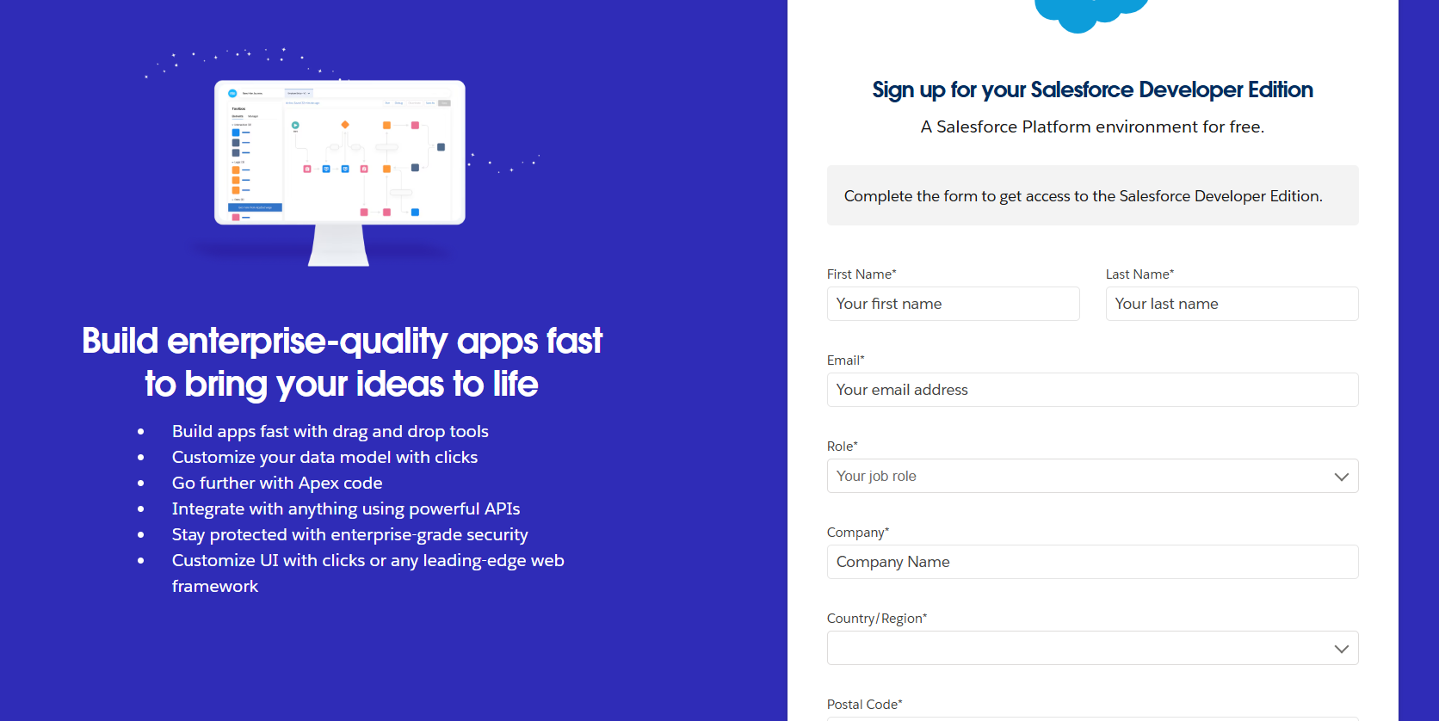

1. Activate your account by clicking on the verify account that is sent to your mail.

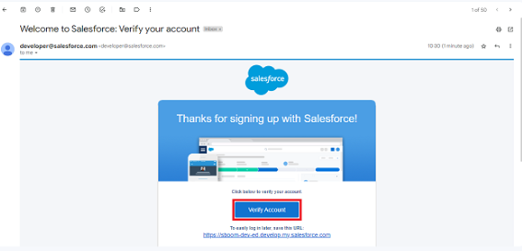

**Task 2: Creating Objects**

1.Create Supplier object

1. From the setup page >> Click on Object Manager>> Click on Create>>Click on Custom Object.
2. Enter the label name>>supplier
3. Plural label name>>supplier
4. Enter Record Name Label and Format

* Record Name >> supplier Name
* Data Type>>Text

1. Click on Allow reports and Track Field History and allow search
2. Allow search >> Save.

.

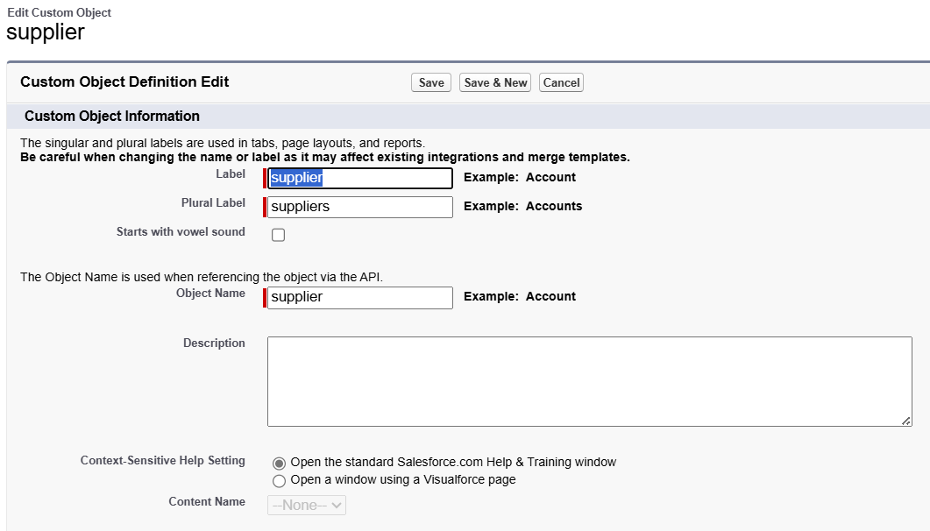

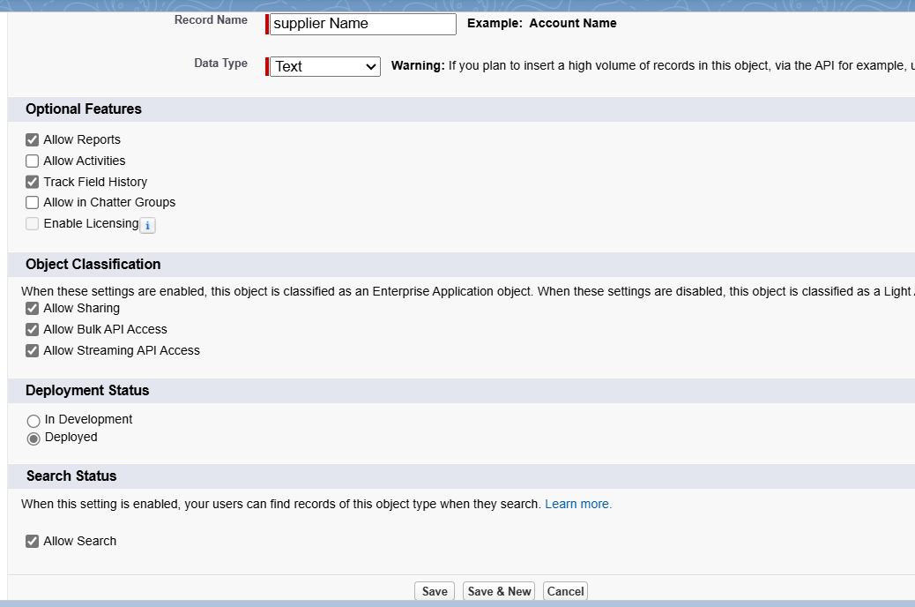

2.Create rice mill object.

1. From the setup page >> Click on Object Manager>>Click on Create >> Click on Custom Object.
2. Enter the label name>>rice mill
3. Plural label name>> rice mills
4. Enter Record Name Label and Format

* Record Name >>
* Data Type >> Auto Number
* Display Format >> rice-{000}
* Starting number >> 1

1. Click on Allow reports and Track Field History, Allow Search and Save.

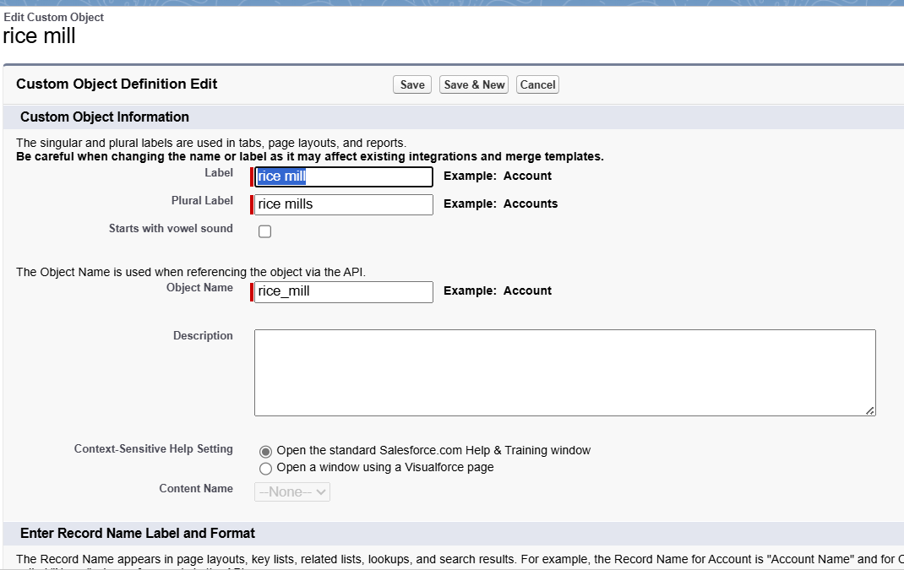

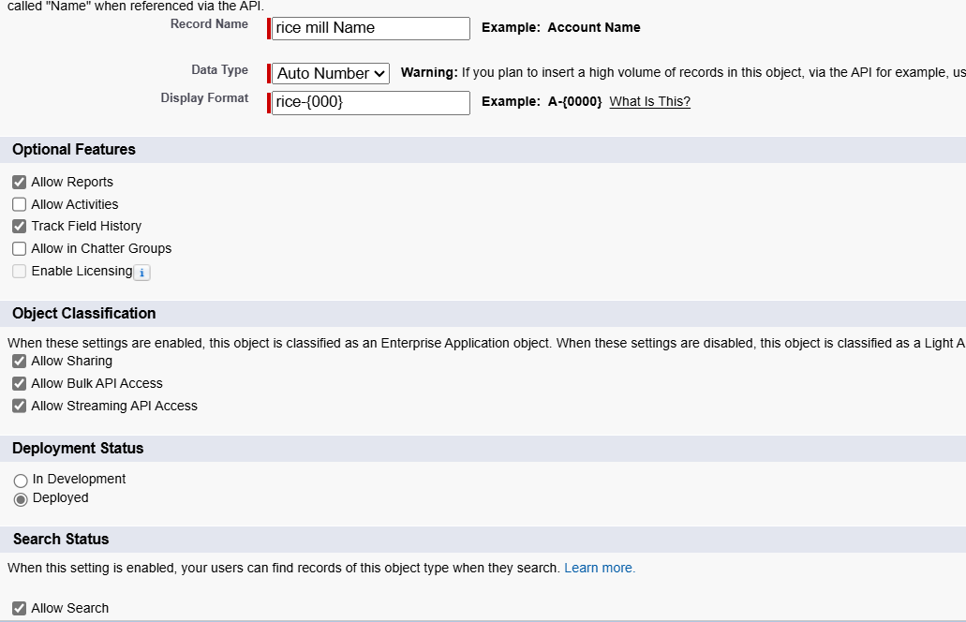

3.Create consumer object.

1. Use these display format for the consumer

* label name >> consumer
* Plural label name >> consumers
* Display Format >> consumers-{000}
* Starting number >> 1

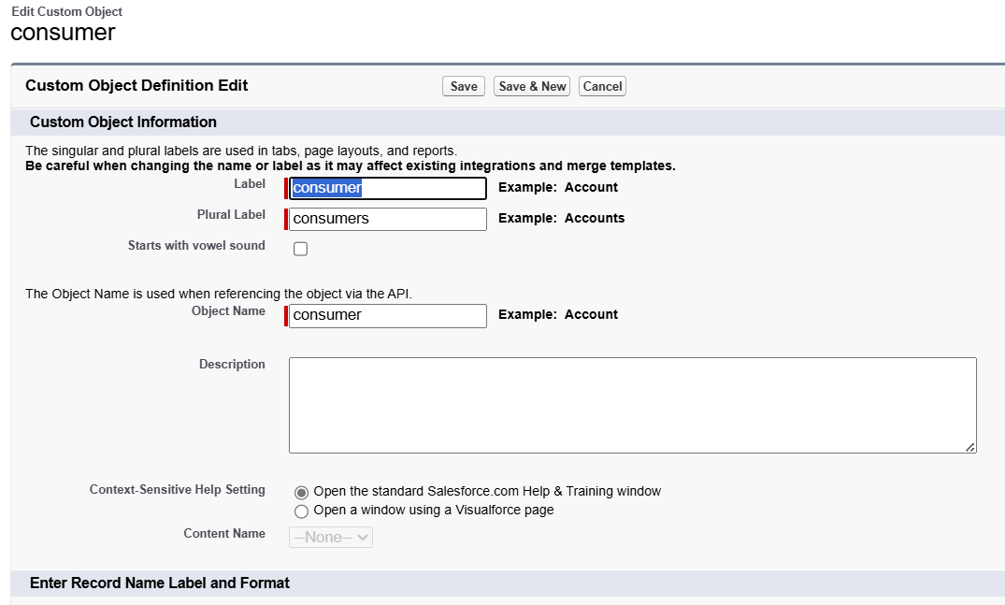

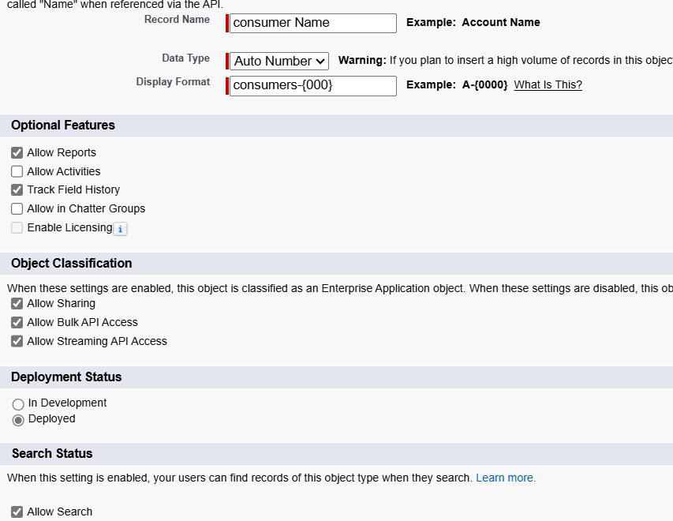

4.Create rice details object.

1. Use these display format for the rice details

* label name >> rice details
* Plural label name >> rice details
* Display Format >> rice-{000}
* Starting Number >>1

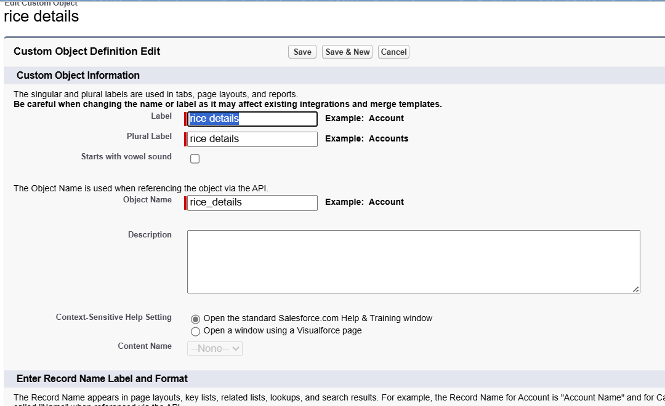

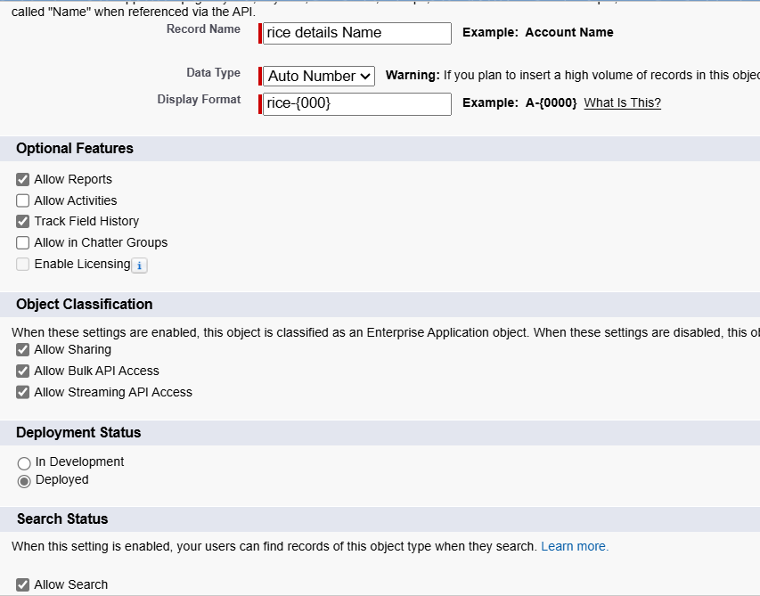

**Task 3: Creating Tabs**

Create a custom tab for supplier object.

1. Go to setup page >> type Tabs in Quick Find bar >> click on tabs >> New (under custom object tab)
2. Select Object( supplier) >> Select the tab style >> Next (Add to profiles page) keep it as default >> Next (Add to Custom App) uncheck the include tab .
3. Make sure that the Append tab to users' existing personal customizations is checked.
4. Click save.

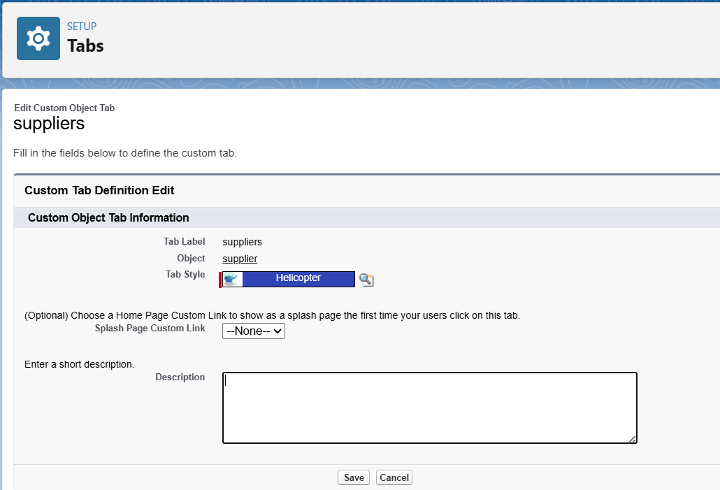

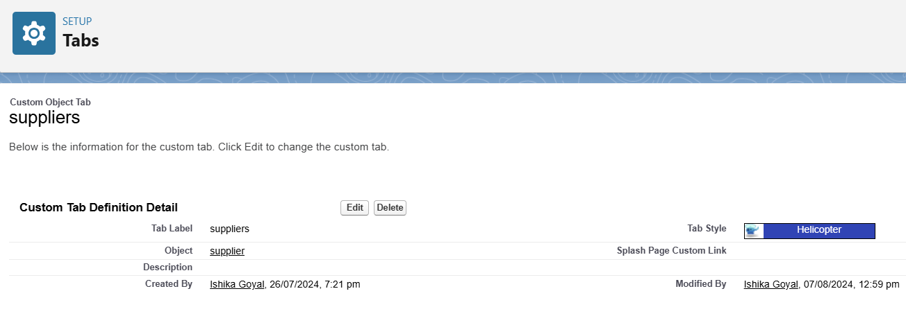

Create a custom tab for rice mill object.

1. Go to setup page >> type Tabs in Quick Find bar >> click on tabs >> New (under custom object tab)
2. Select Object( rice mill) >> Select the tab style >> Next (Add to profiles page) keep it as default >> Next (Add to Custom App) uncheck the include tab .
3. Make sure that the Append tab to users' existing personal customizations is checked.
4. Click save.

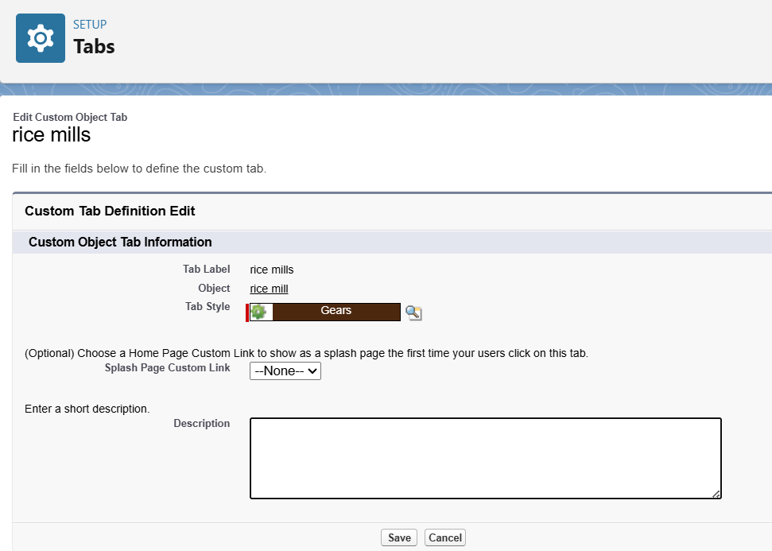

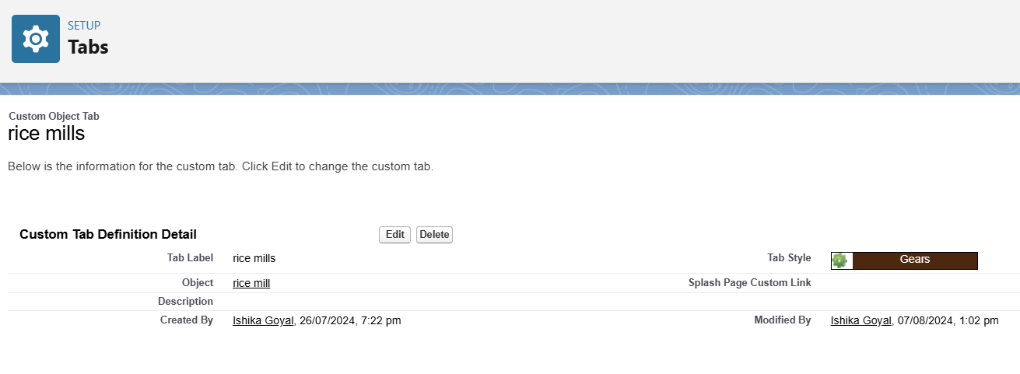

Create a custom tab for consumer object.

1. Go to setup page >> type Tabs in Quick Find bar >> click on tabs >> New (under custom object tab)
2. Select Object(consumer) >> Select the tab style >> Next (Add to profiles page) keep it as default >> Next (Add to Custom App) uncheck the include tab .
3. Make sure that the Append tab to users' existing personal customizations is checked.
4. Click save.

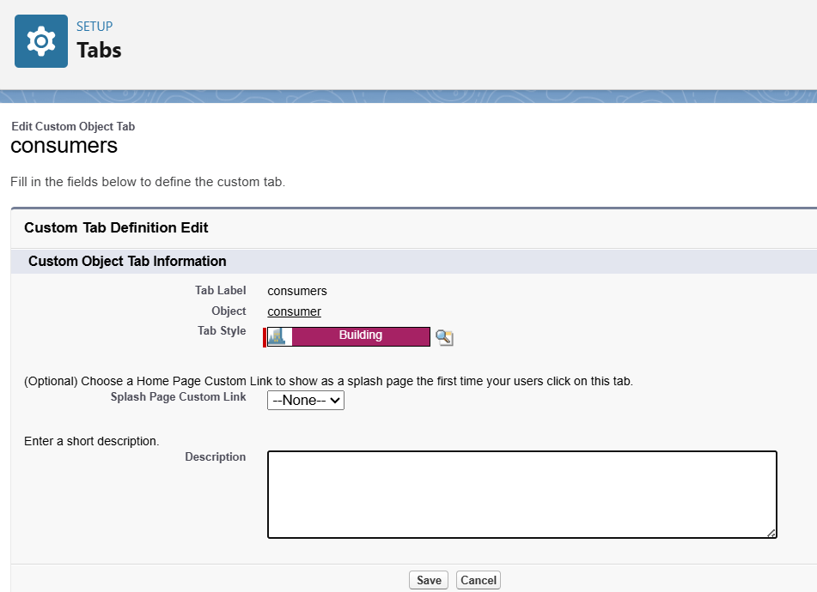

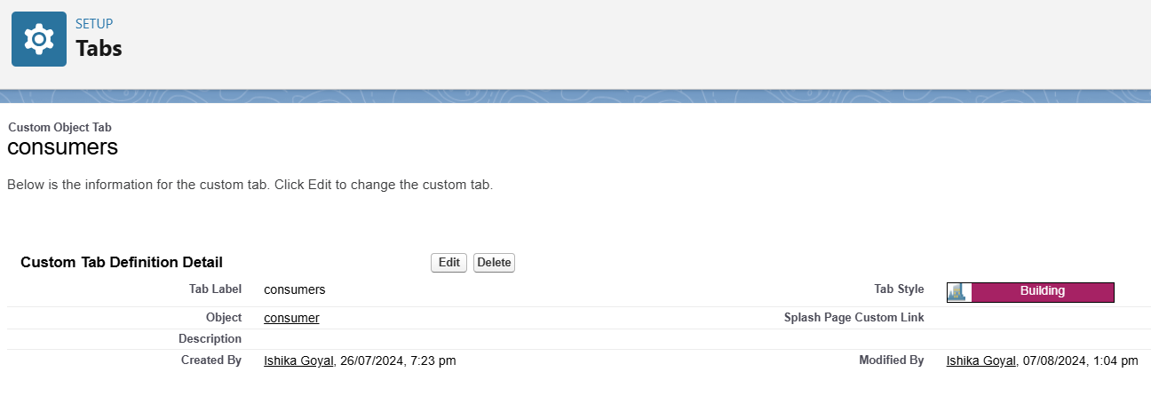

Create a custom tab for rice details object.

1. Go to setup page >> type Tabs in Quick Find bar >> click on tabs >> New (under custom object tab)
2. Select Object(rice details) >> Select the tab style >> Next (Add to profiles page) keep it as default >> Next (Add to Custom App) uncheck the include tab .
3. Make sure that the Append tab to users' existing personal customizations is checked.
4. Click save.

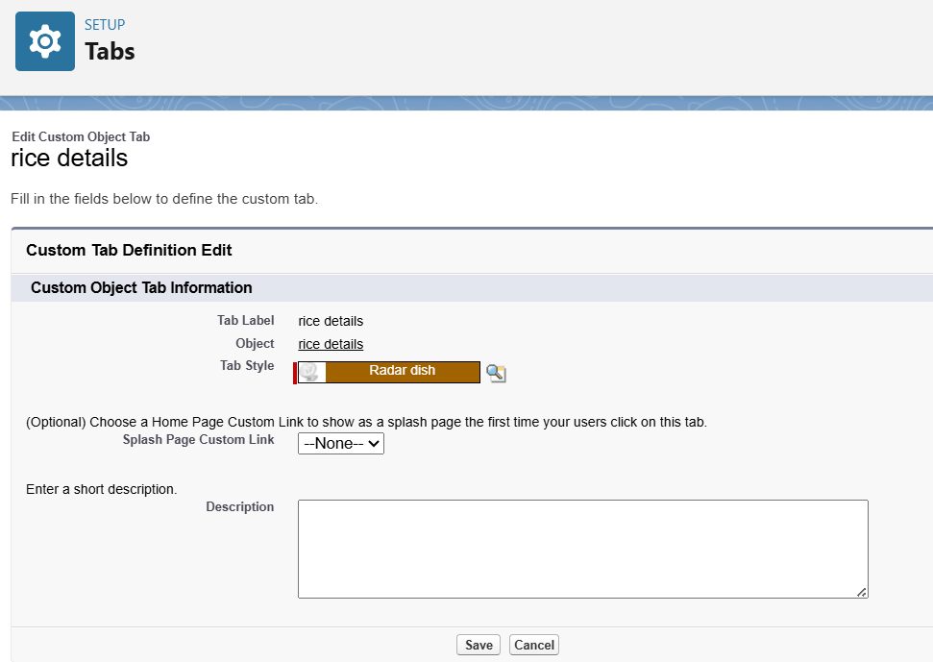

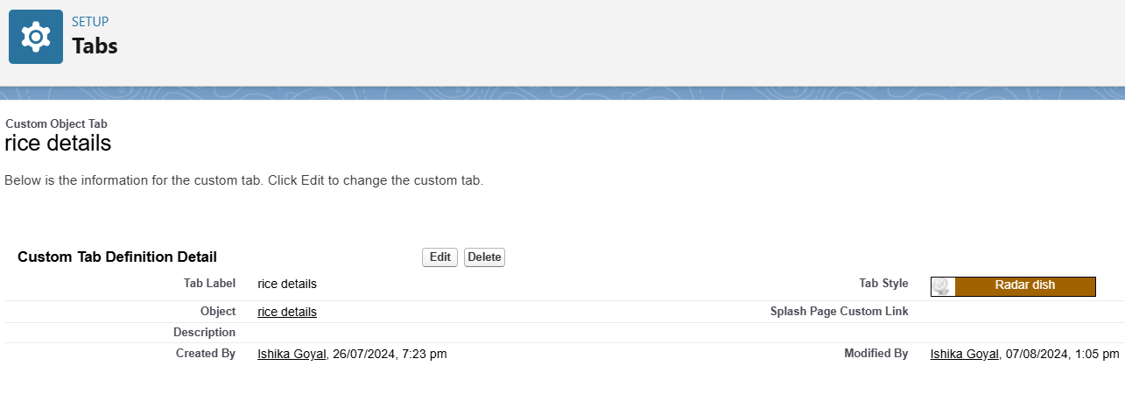

**Task 4: Creating a Lightning app**

To create a lightning app page:

1. Go to setup page >> search “app manager” in quick find >> select “app manager” >> click on New lightning App.

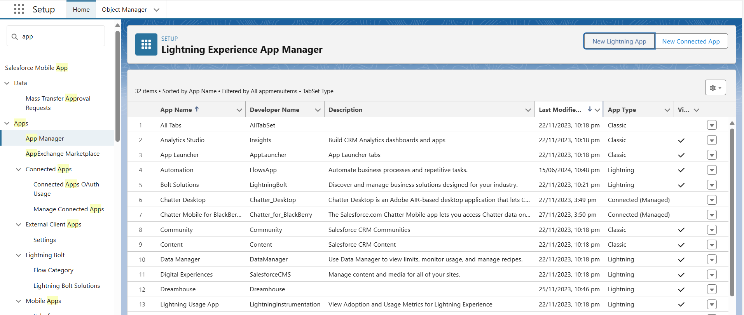

1. Fill the app name in app details as MY RICE >> Next >> (App option page) keep it as default >> Next >> (Utility Items) keep it as default >> Next.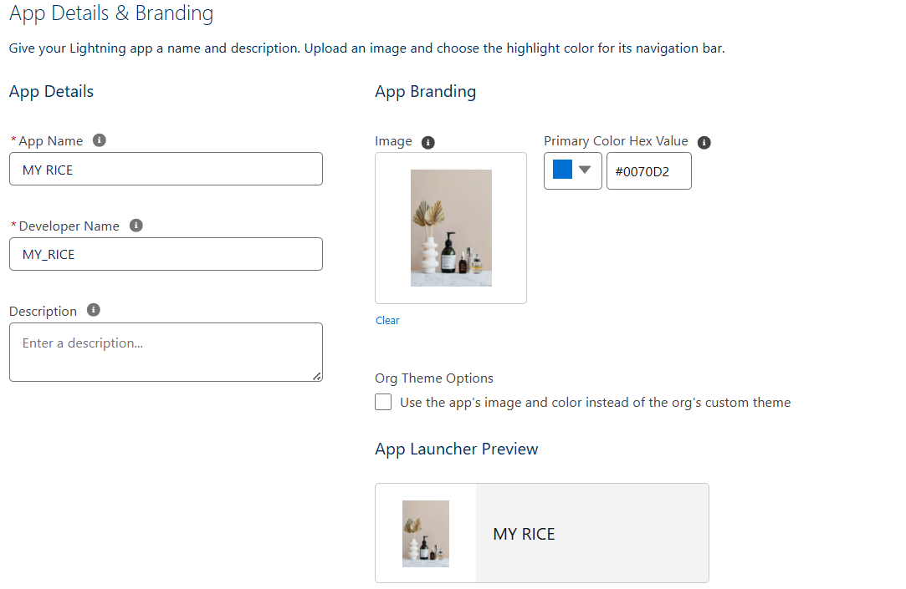
2. Upload a photo that is related to your app.
3. To add Navigation Item:

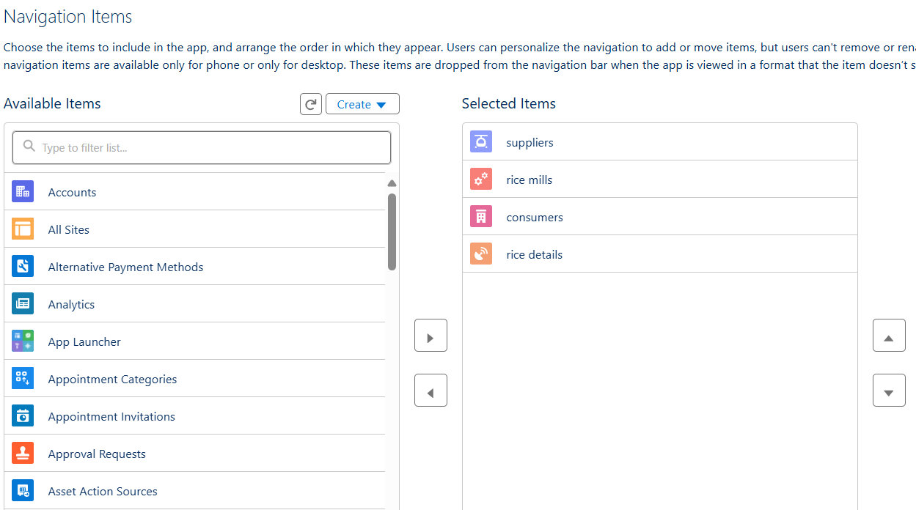

1. Select the items (supplier, rice mill, consumer
2. To Add User Profiles:

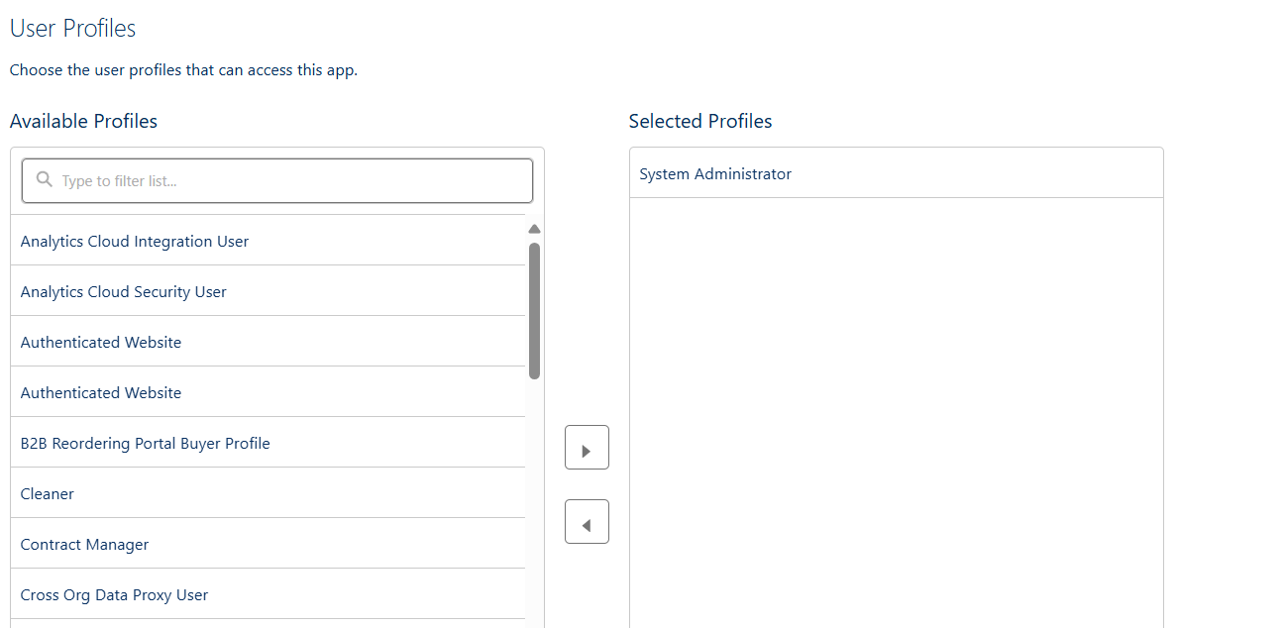

Search profiles (System administrator) in the search bar >> click on the arrow button >> save & finish.

**Task 5: Creating Fields**

**Creating the number field in rice details object**

1. Go to the setup page >> click on object manager >> From drop down click edit for rice details object.
2. Click on fields & relationship >> click on New.

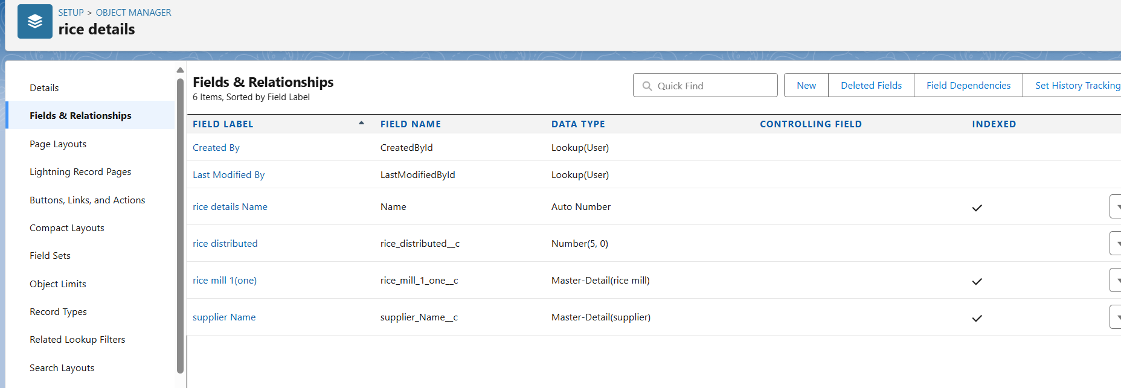

1. Select Data type as “Number” and click Next.
2. Given the Field Label as “ rice distributed ” and length as “ 5 ”.  
   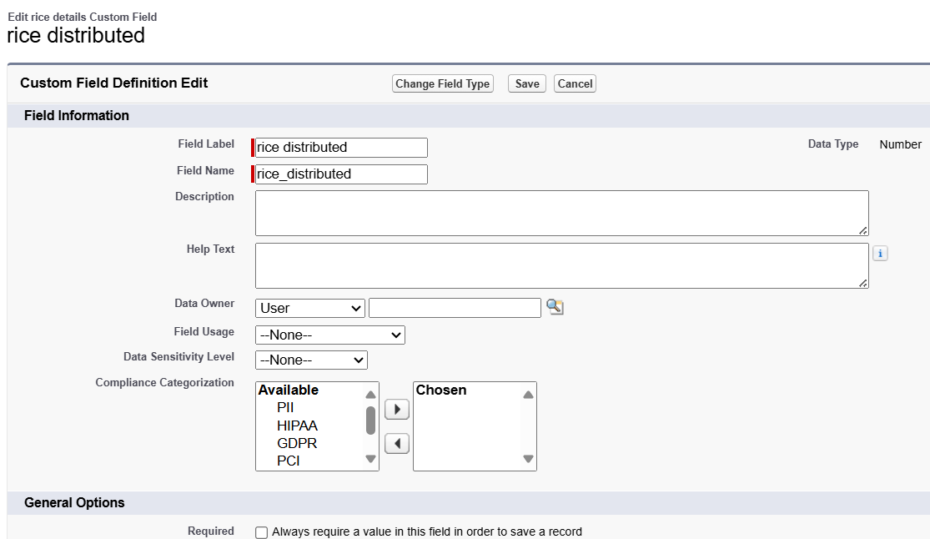
3. Field Name will be auto populated, and click on Next- Next >> Save.

**Creating junction object as rice details with supplier & rice mill**

To create junction object

1.Go to the setup page >> click on object manager >> From drop down click edit for rice details object.

1. Click on fields & relationship - click on New.
2. Select “Master-Detail relationship” as data type and click Next.
3. Select the related object “ supplier ” and click next.
4. Give Field Label as “supplier Name” and click Next.
5. Next >> Next >> Save & New.

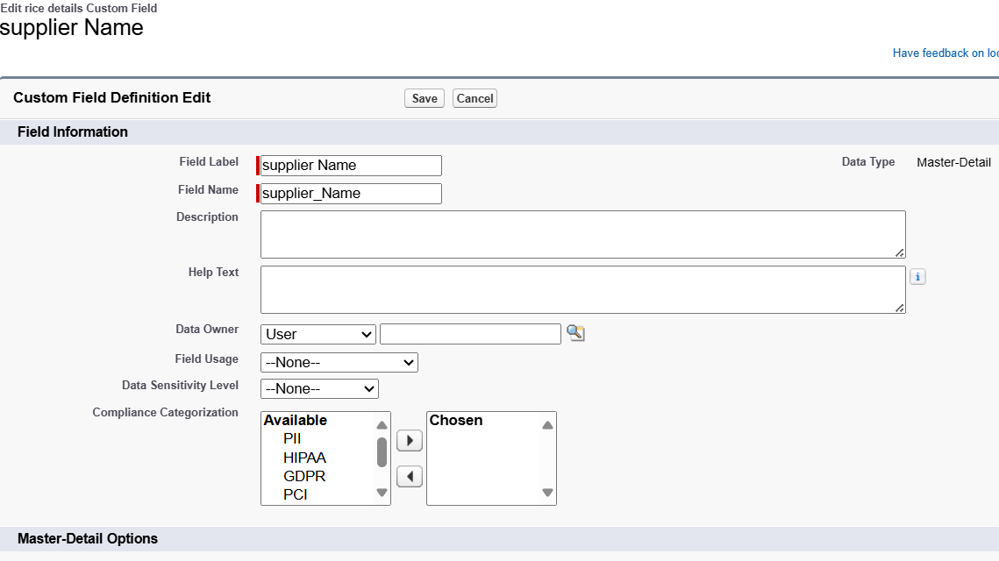

1. Follow the same steps from 1 to 3.
2. Select the related object “ rice mill ” and click Next.
3. Give Field Label as “rice mill 1(one)” and click Next.
4. Next >> Next >> Save.

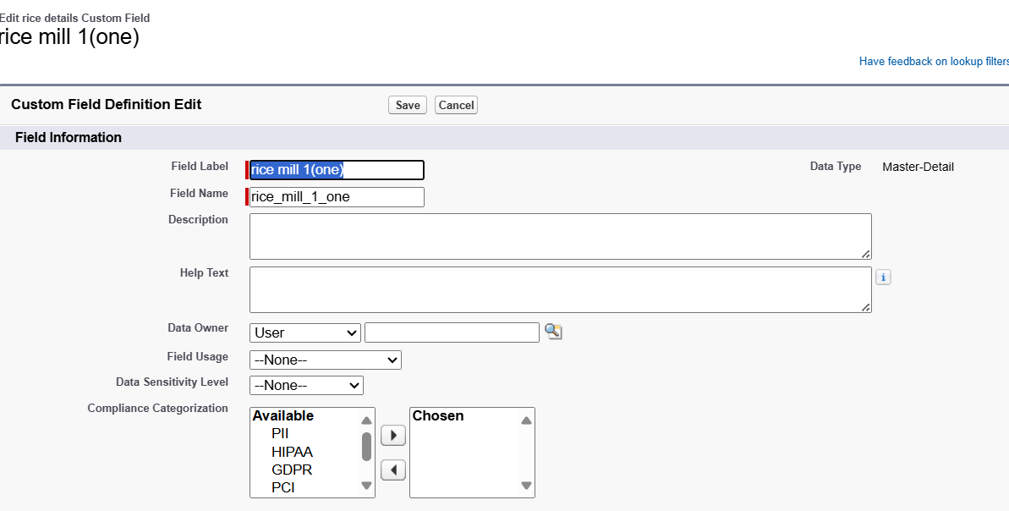

**Creating Master-Detail Relationship between consumer & rice mill Object**

To Create a Master-Detail relationship

1. Go to the setup page >> click on object manager >> From drop down click edit for consumer object.
2. Click on fields & relationship >> click on New.
3. Select “Master-Detail relationship” as data type and click Next.
4. Select the related object “ rice mill”.
5. Give Field Label as “rice mill name” and click Next.
6. Next >> Next >> Save.

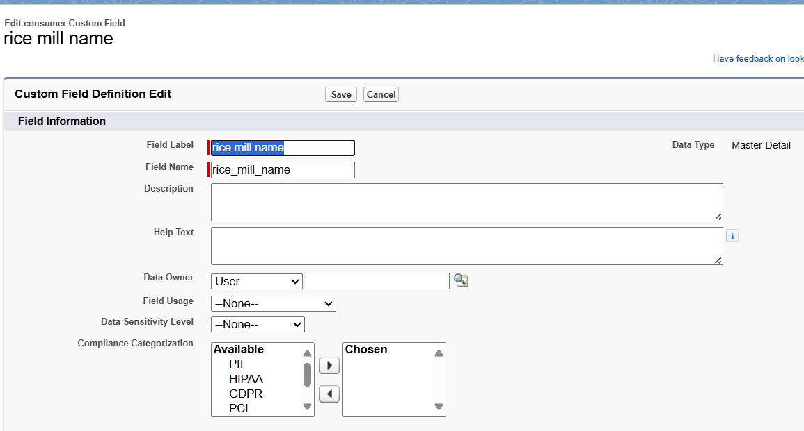

**Creating the Roll-up summary field on supplier & rice mill Objects.**

1. Go to setup >> click on Object Manager >> type object name(supplier) in search bar >> click on the object.
2. Now click on “Fields & Relationships” >> New
3. Select the data type as “Rollup summary ”,and click Next.
4. Give the Field label as “ sum of rice distributed ”,Field Name will be Auto generated, and click Next.

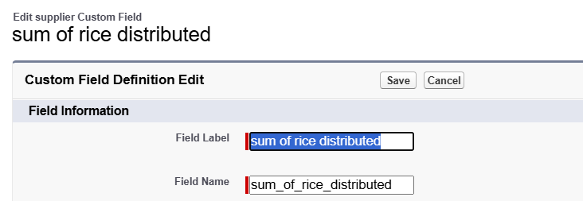

1. Select the summarized object as “ rice details ”.
2. Select the Rollup type as “sum”.
3. Select the field to aggregate as “ rice distributed ”, and click Next >>Next >>Save.

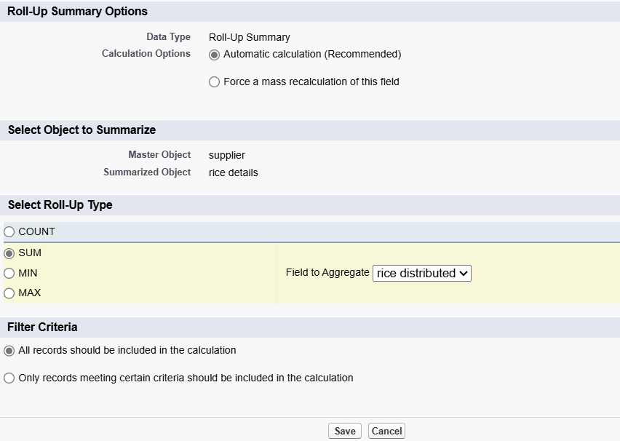

1. Follow the same steps for the rice mill Object from 1 to 3
2. Give the Field label as “ rice distributed to shops ”,Field Name will be Auto generated, and click Next.

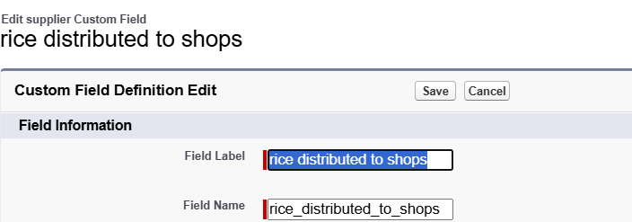

1. Select the summarized object as “ rice details ”.
2. Select the Rollup type as “sum”.
3. Select the field to aggregate as “ rice distributed ”, and click Next >> Next >> Save.

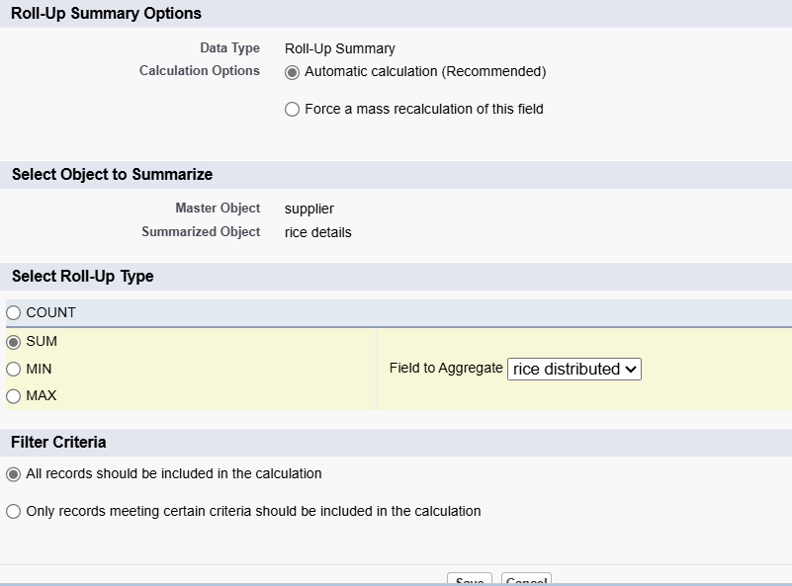

1. create the field as “ rice taken by shops in kgs” using number datatype in consumer object.

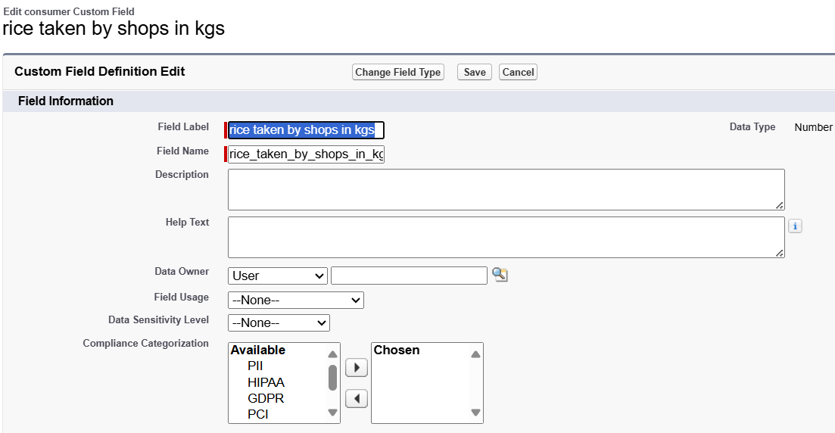

1. Follow the same steps for the rice mill Object from 1 to 3
2. Give the Field label as “ rice taken ”,Field Name will be Auto generated, and click Next.

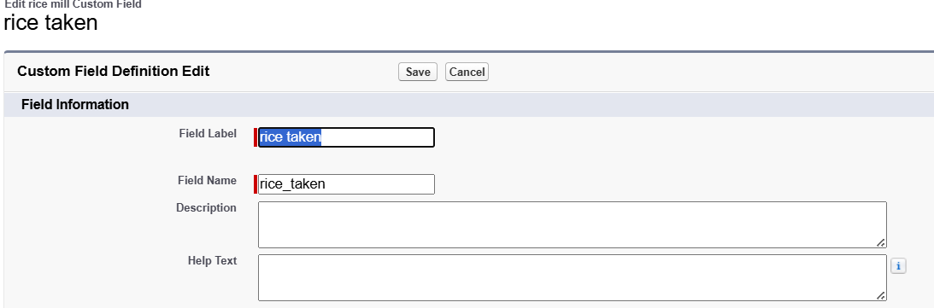

1. Select the summarized object as “ consumer”.
2. Select the Rollup type as “sum”.
3. Select the field to aggregate as “ rice taken in shops ”, and click Next >> Next >> Save.

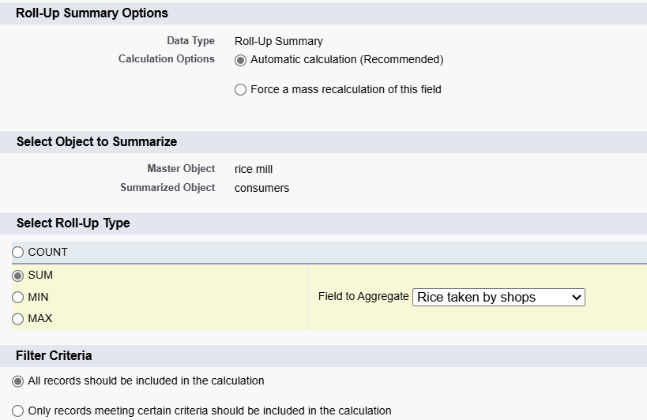

**Creating the number field in rice details object**

1. Go to the setup page >> click on object manager >> From drop down click edit for rice details object.
2. Click on fields & relationship >> click on New.
3. Select Data type as “master detail” and click Next.
4. Given the Field Label as “ supplier name ” and length as “ 5
5. Field Name will be auto populated, and click on Next>> Next >>Save.

### **Creating Fields in rice mill Objects**

1. Select Data type as “Number” and click Next.
2. Given the Field Label as “ rice price/kg ” and length as “ 5 ”

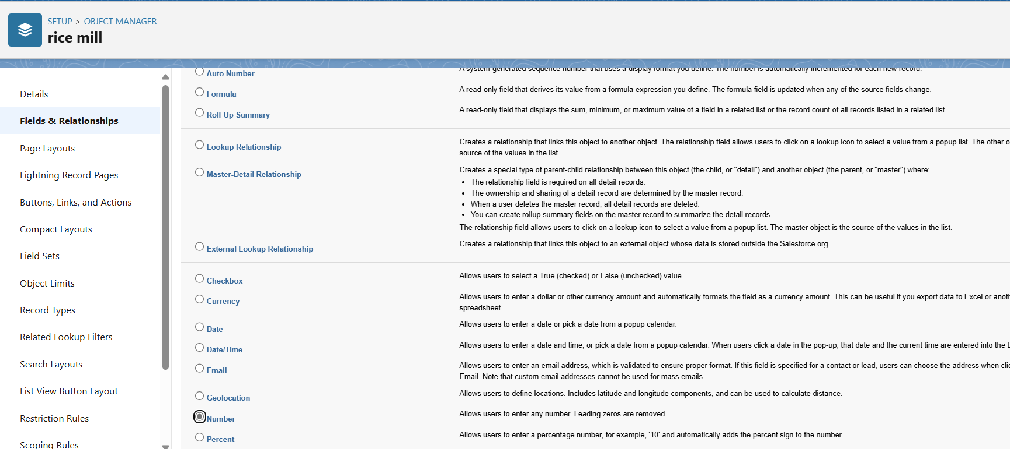

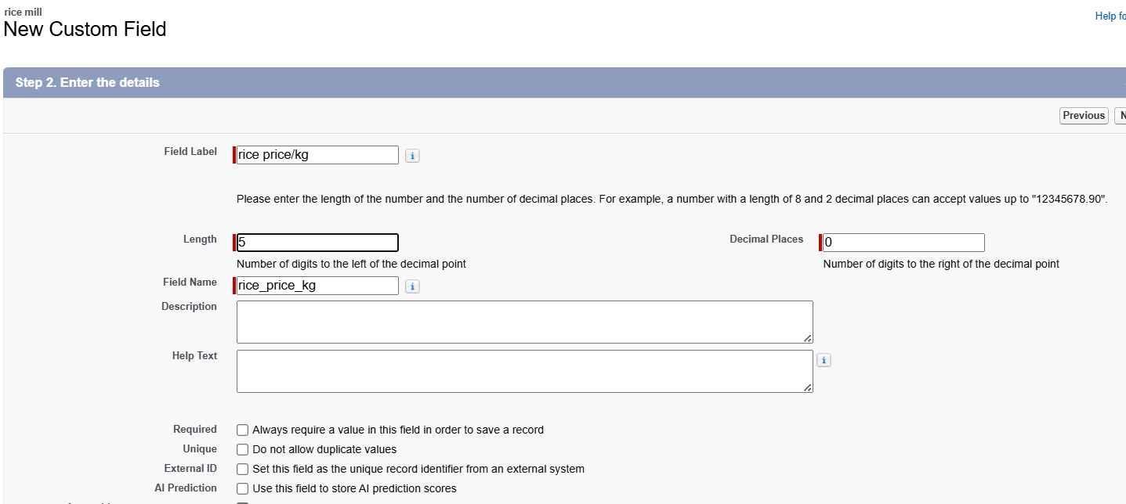

### **Creating Fields in consumer Objects**

1. Create a “First name” field, Data Type - “text”.

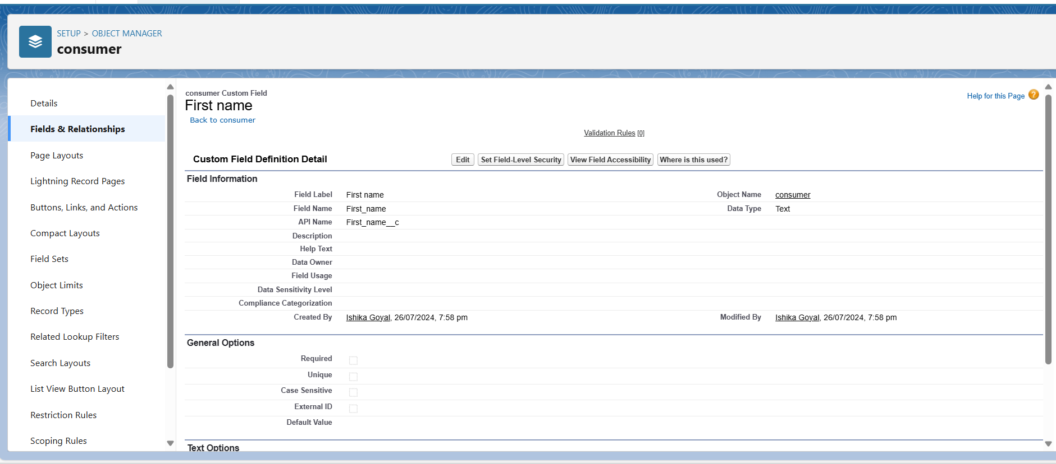

1. Create a “Last name” field, Data Type - “text”.

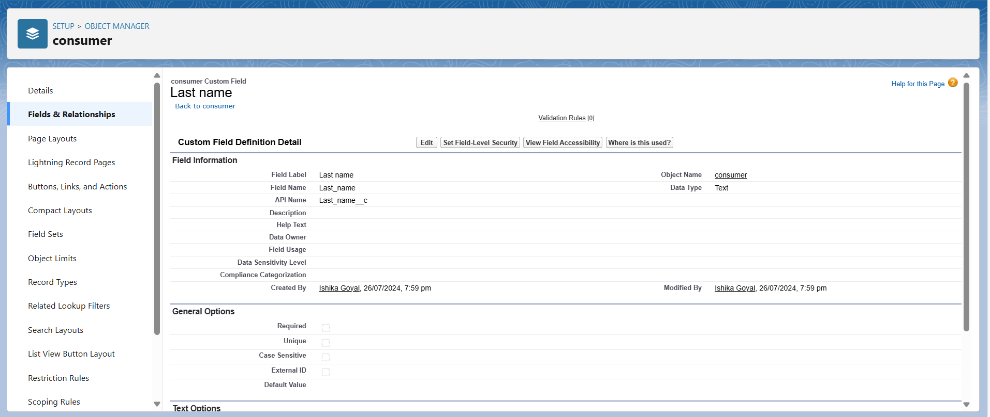

1. Create a “Phone number” field, Data Type - “phone”.

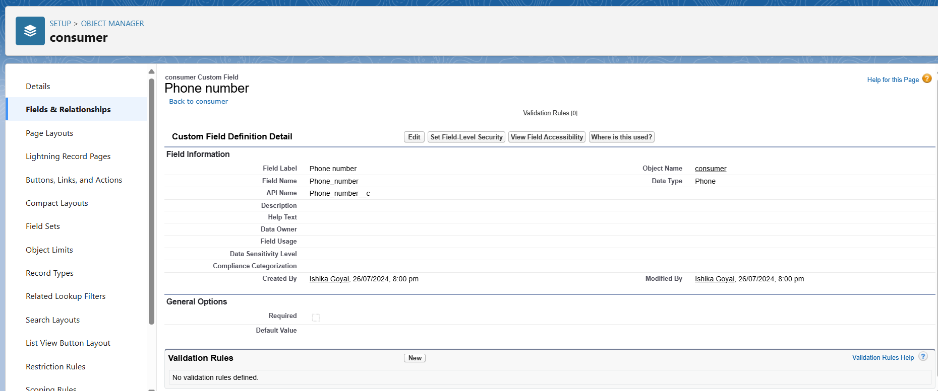

1. Create a “email” field, Data Type - “email”.

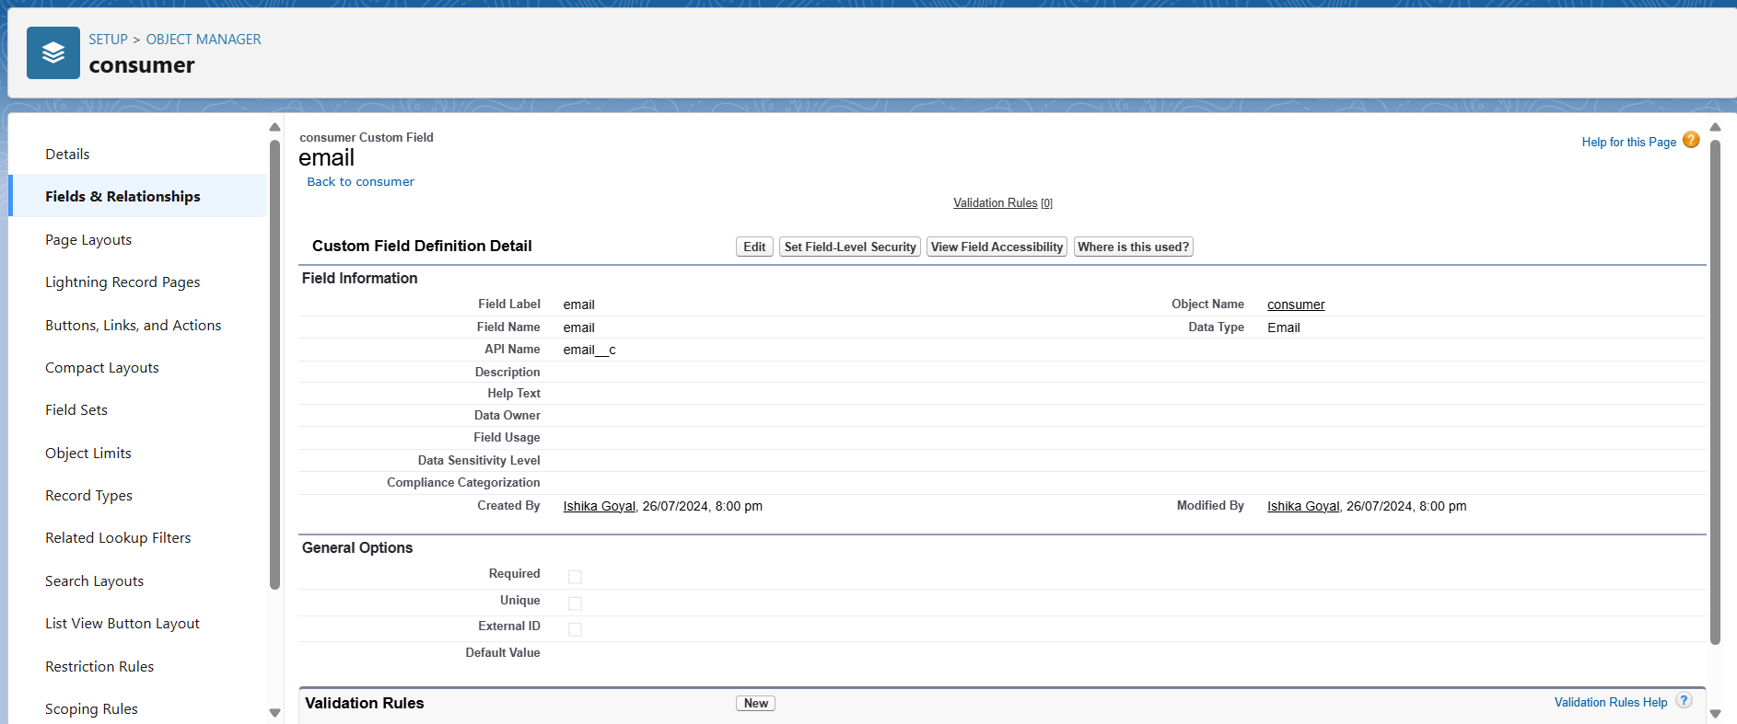

1. Create a “Rice taken by shops” field, Data Type - “Number”,length=5.

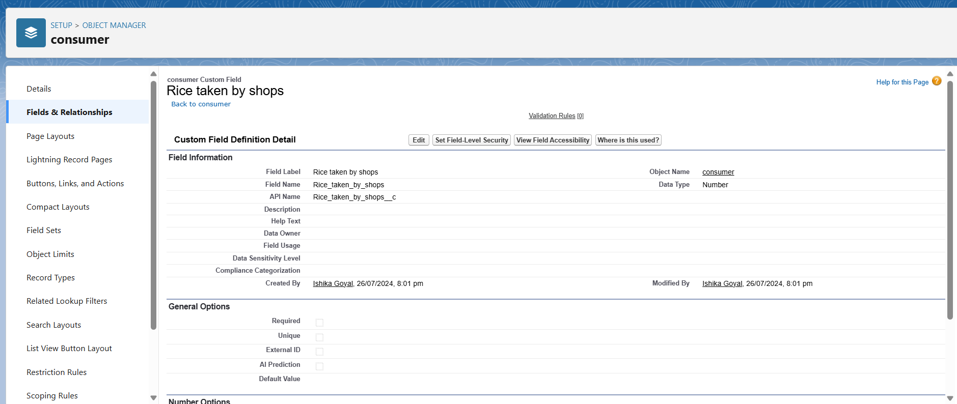

1. Create a “Rice type” field, Data Type - “Picklist”.

Picklist values-

1. Basmati

2. Normal rice

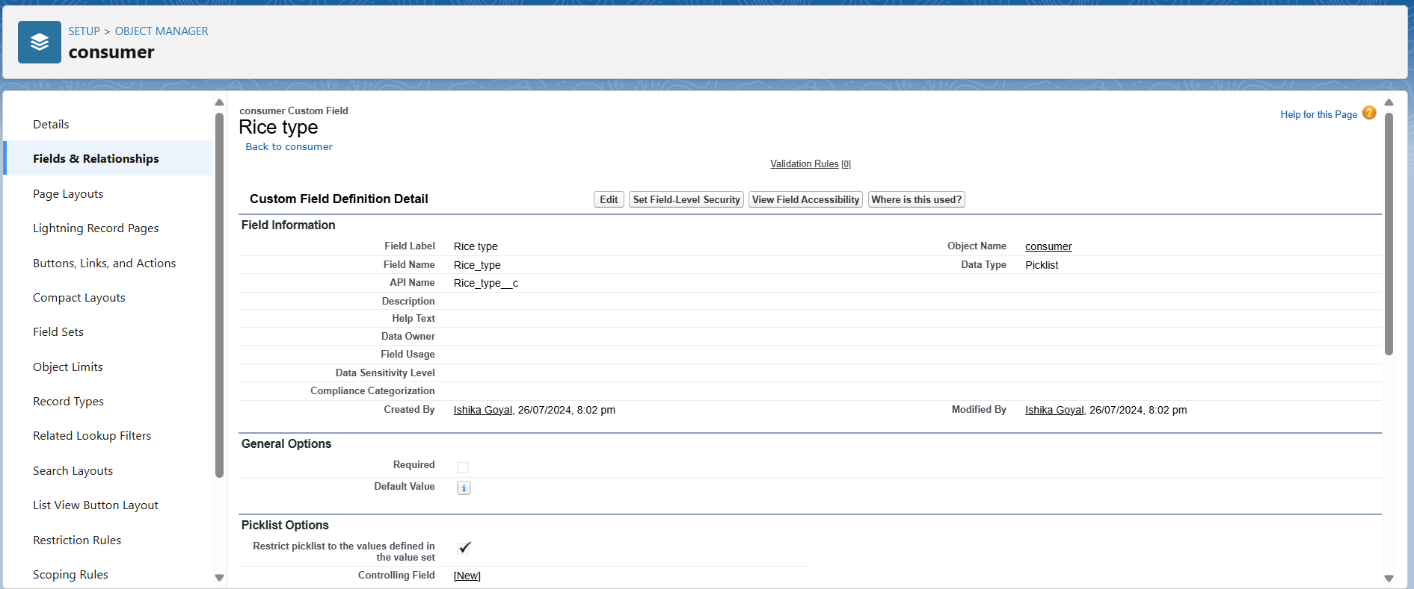

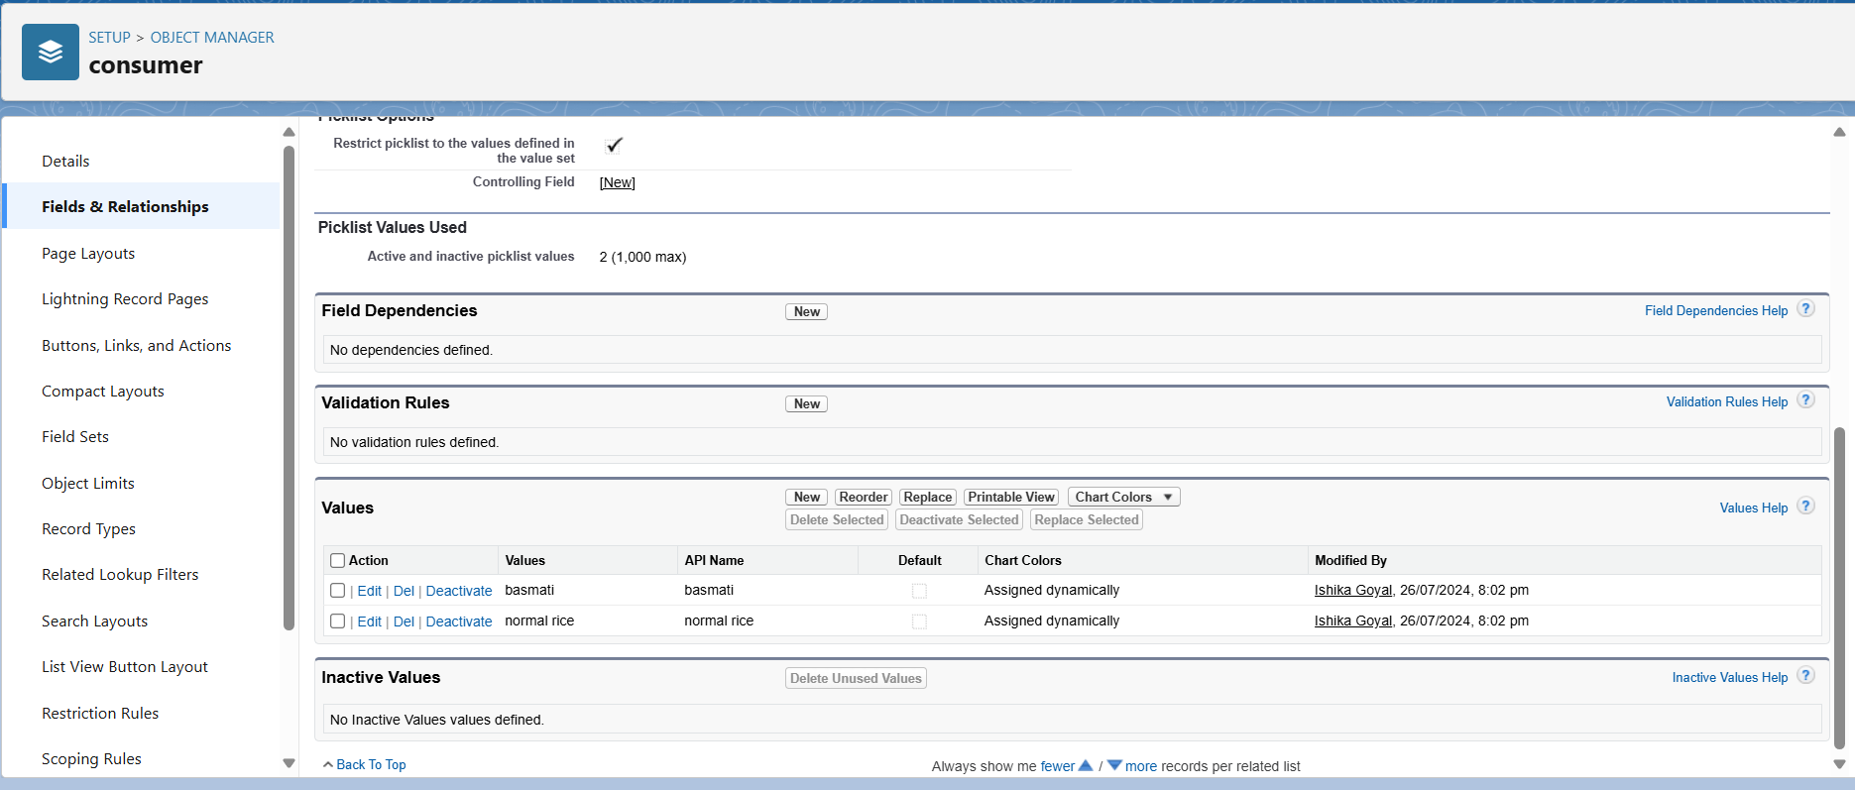

1. Create a “Mode of payment” field, Data Type - “Picklist”.

Picklist values-

* Credit card
* Debit card
* Net banking
* UPI
* Cash

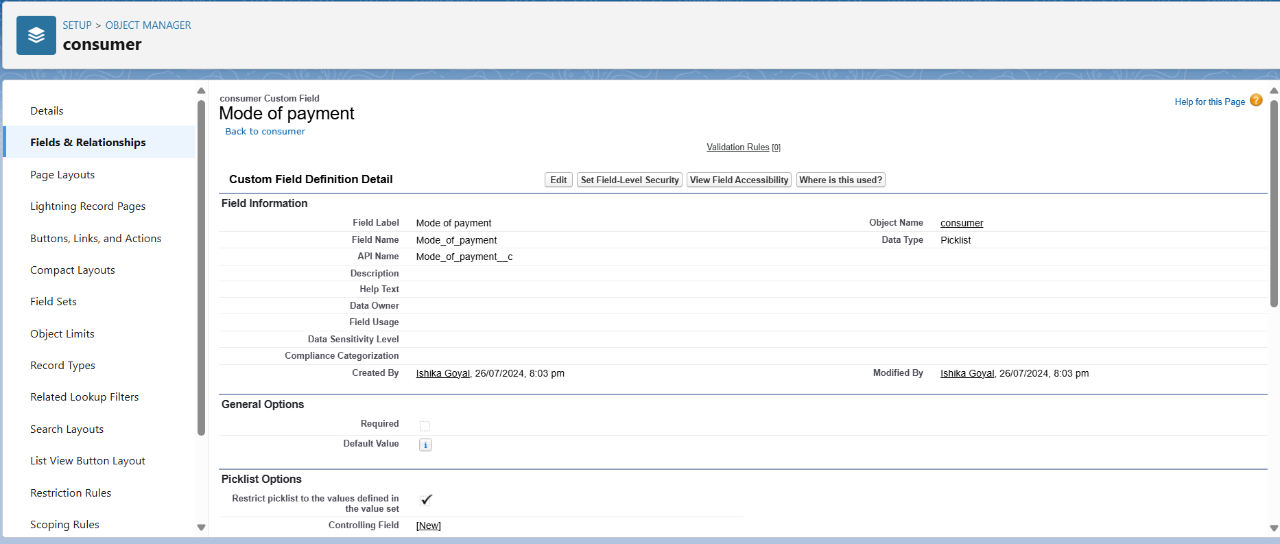

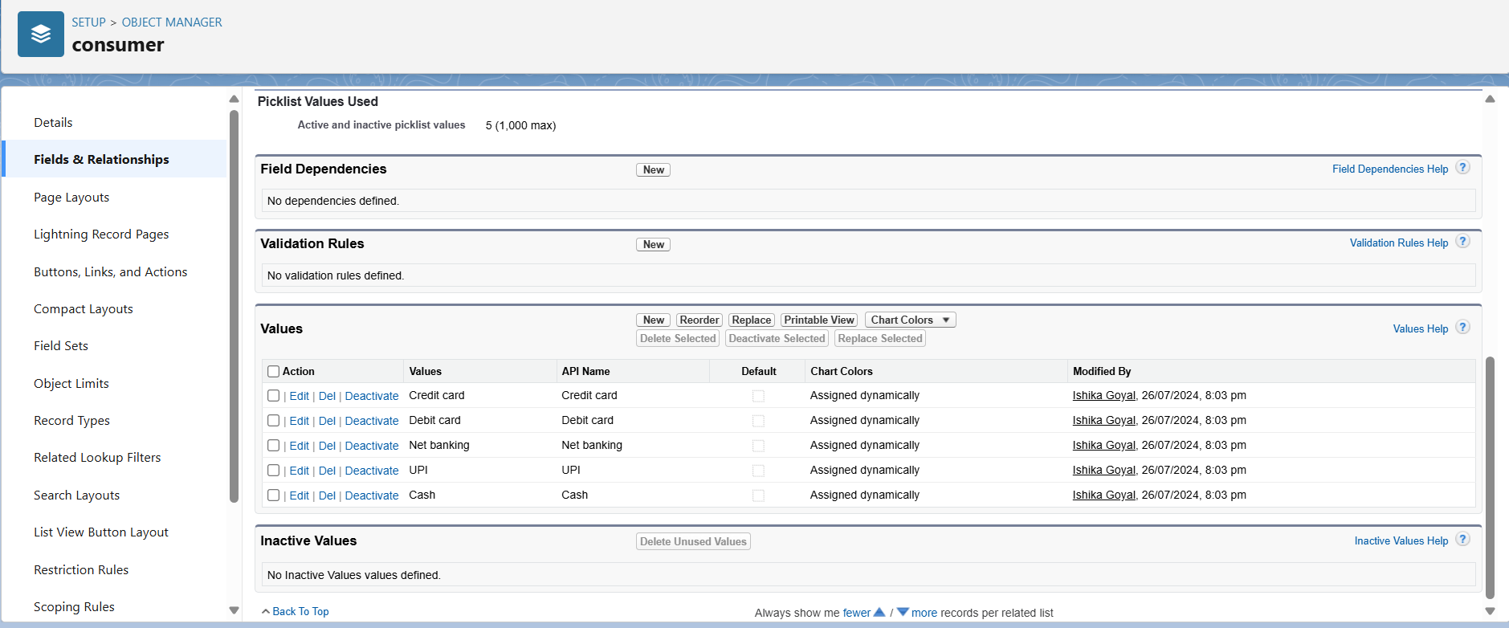

### **Creating Cross Object Formula Field in consumer Object**

1. Go to setup >> click on Object Manager >> type object name(consumer) in search bar >> click on the object.
2. Click on fields & relationship >> click on New.
3. Select Data type as “Formula” and click Next.
4. Give Field Label and Field Name as “Amount Paid ” and select formula return type as “Number” and click next.

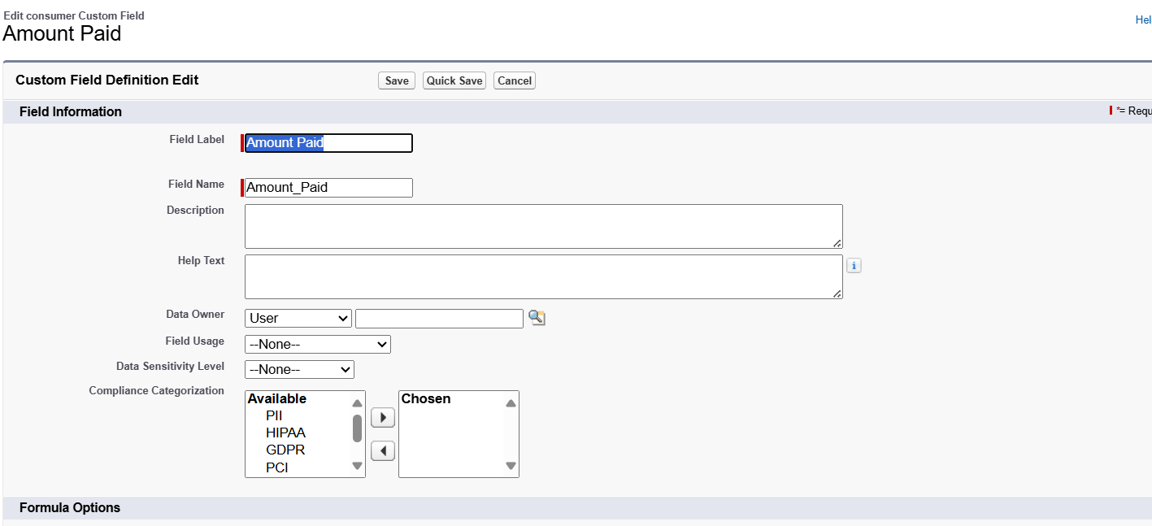

1. Insert fields formula should be :

rice_taken_by_shops__c * rice_mill_name__r.rice_price_kg__c

1. Under Advanced Formula write down the formula and click “Check Syntax” and Save.

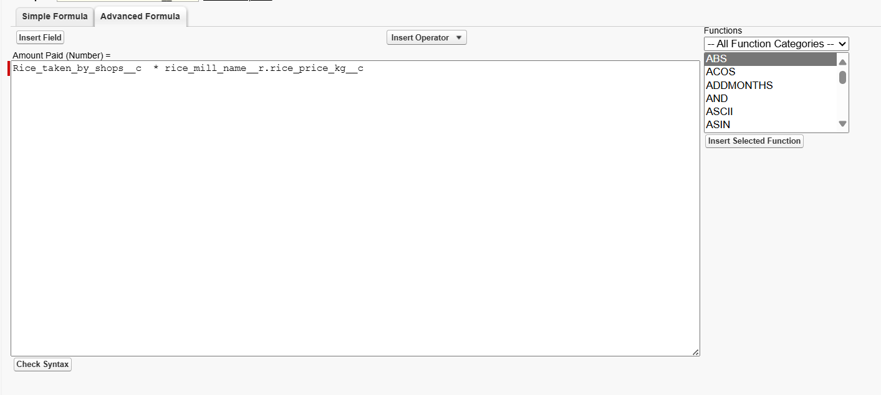

1. Creating the Formula field in consumer Object
2. Go to setup >> click on Object Manager >> type object name(consumer) in search bar >> click on the object.
3. Click on fields & relationship >> click on New.
4. Select Data type as “Formula” and click Next.
5. Give Field Label and Field Name as “Consumer Name” and select formula return type as “TEXT” and click next.
6. Insert field formula should be : First_Name__c + ' ' + Last_Name__c
7. click “Check Syntax” and Save.

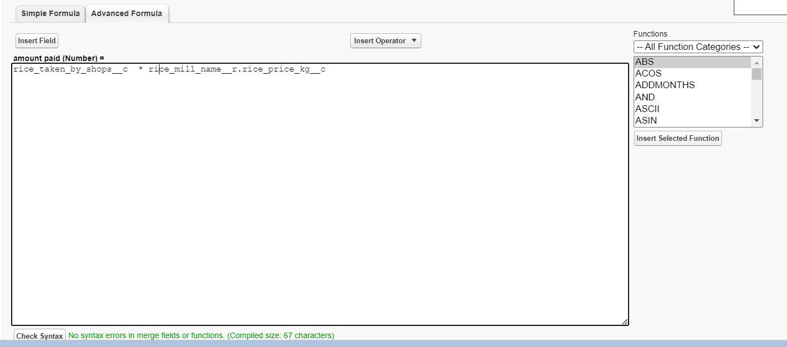

### **Creating the validation rule**

1. Go to the setup page >>click on object manager >> From drop down click edit for consumer object.
2. Click on the validation rule >> click New.  
    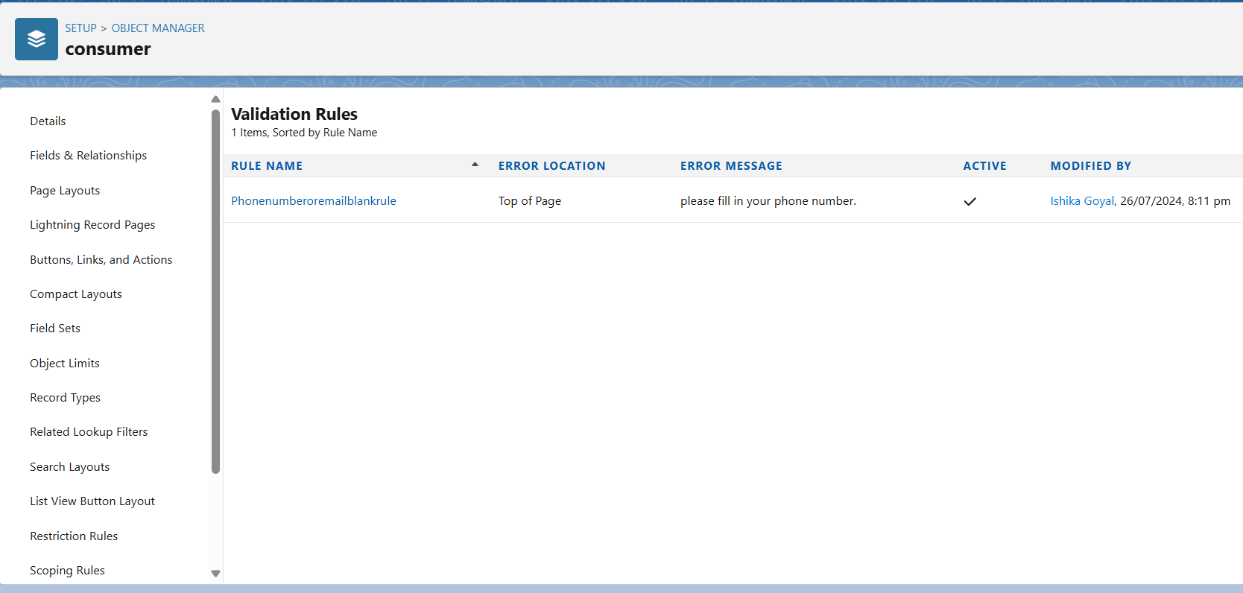
3. Enter the Rule name as “Phonenumberoremailblankrule ”.
4. Enter the description as “phone number and email number should not be blank”.
5. Enter the formula as “OR( ISBLANK( phone_number__c ) , ISBLANK( email__c ) )” and check the syntax.

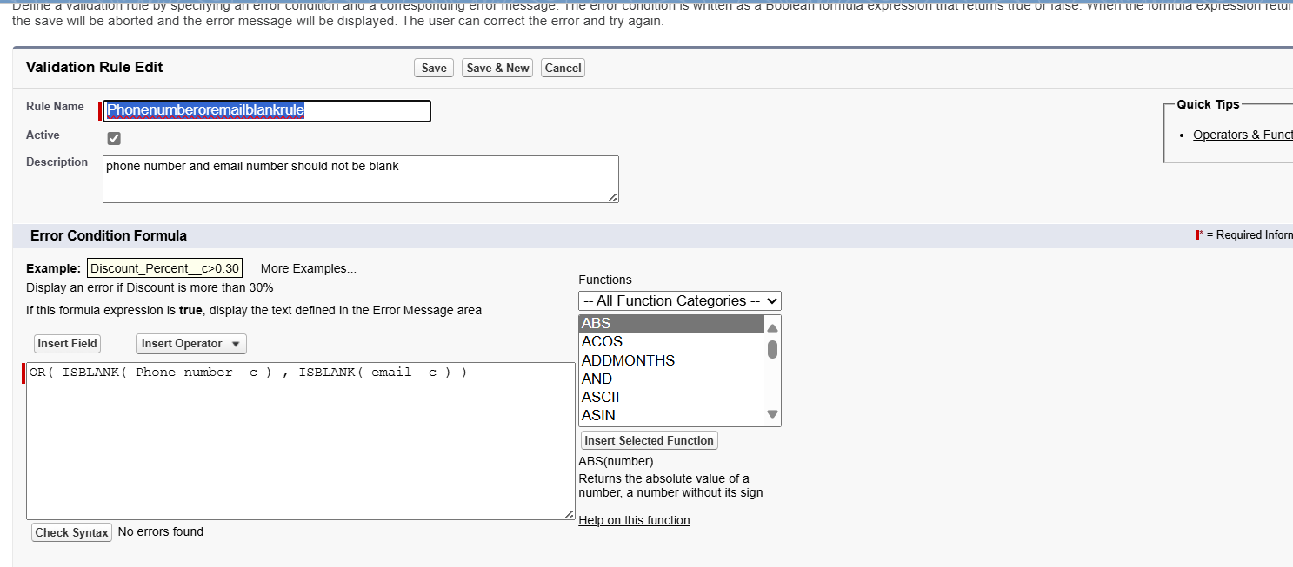

1. Under the error message write as”please fill in your phone number.”
2. Select error location “top of page”.

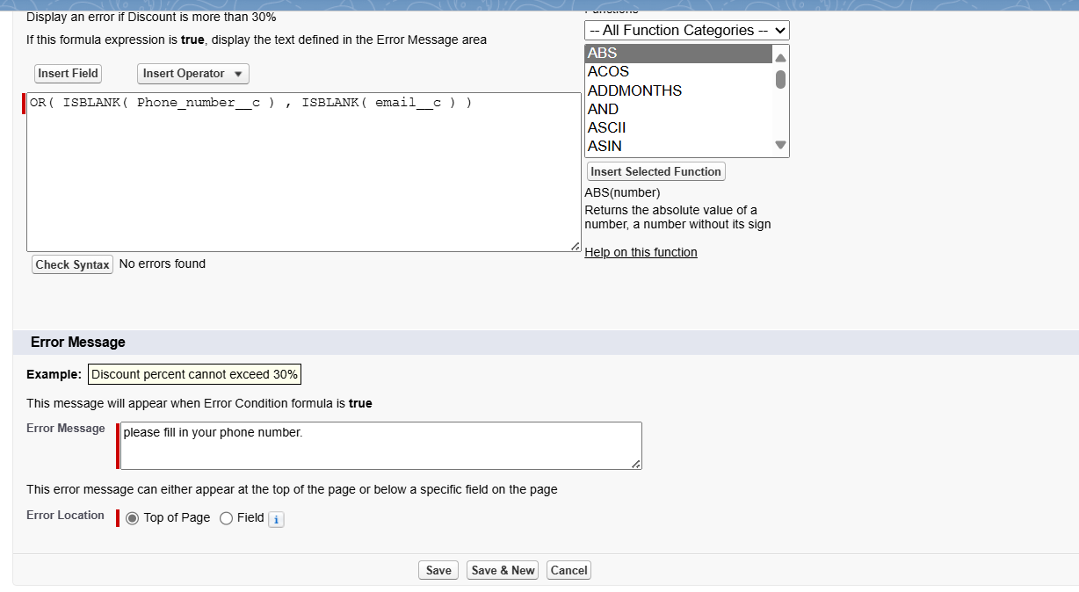

1. Save the validation rule.

**Task 6: Creating a Page Layout**

To Create a Page layout:

1. Go to Setup >> Click on Object Manager >>Search for the object (consumer) >> From drop down select the object and click on it.
2. Click on Page layout >> Click on New.

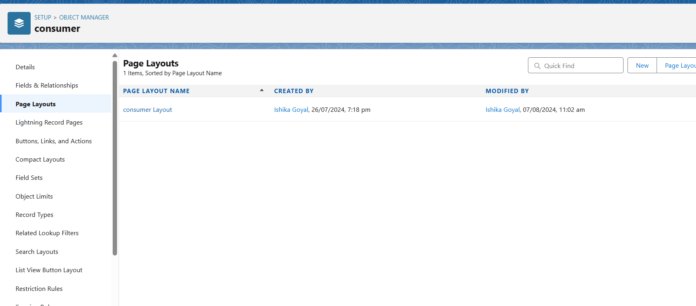

1. Select the existing page layout, and give the page layout name as “consumer layout”, and click save.
2. Drag and drop the section field to consumer details and create the section.
3. Enter the section name as “Personal details”, - click Ok.

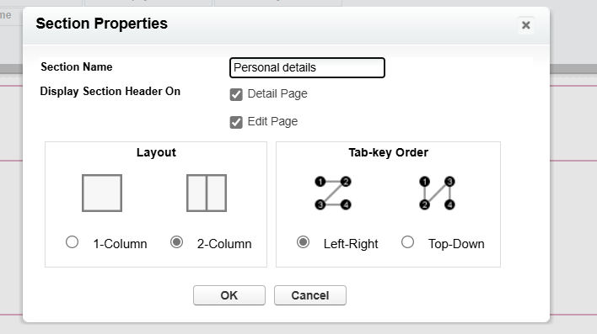

1. Now drag the fields to this section that mentioned , they are

* First name , last name , consumer name , phone number, email, rice mill name.

1. Follow the same process for another two sections as shown above , they are
2. One section is “ rice details ” , drag the fields that are

* Rice taken by shop, rice type.

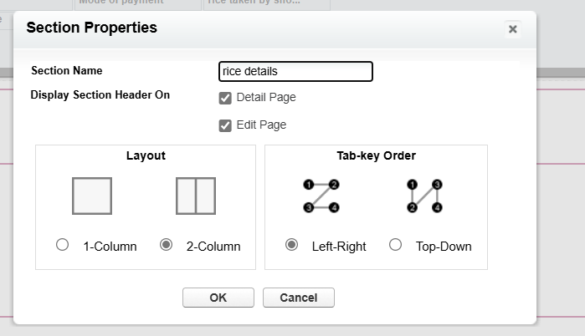

1. Another section is “Receipt details ”, and drag the fields that are

* Mode of payment , Amount paid.

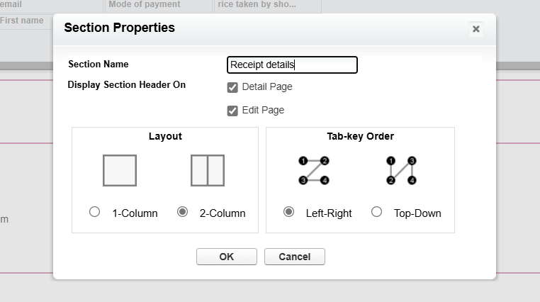

1. Then , Click save.

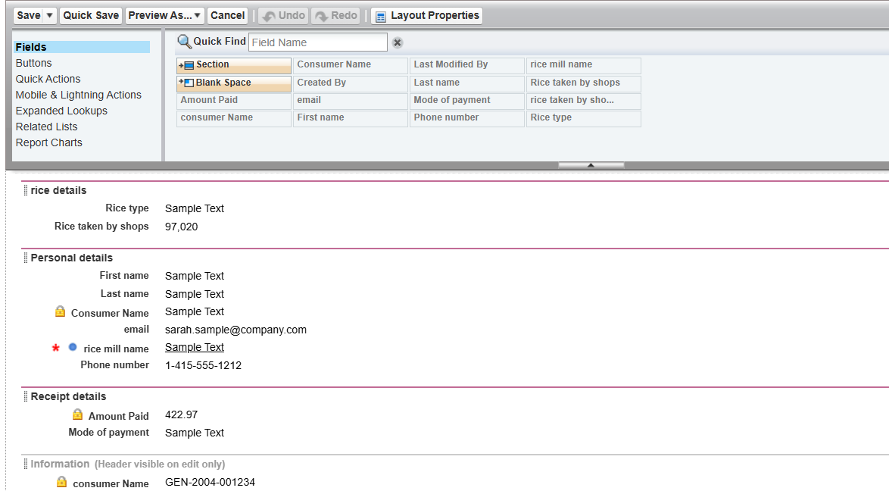

**Task 7: Creating Profiles**

### **Owner Profile**

To create a new profile:

1. Go to setup >> type profiles in quick find box >> click on profiles >> clone the desired profile (Standard User) >>enter profile name (owner) >> Save.

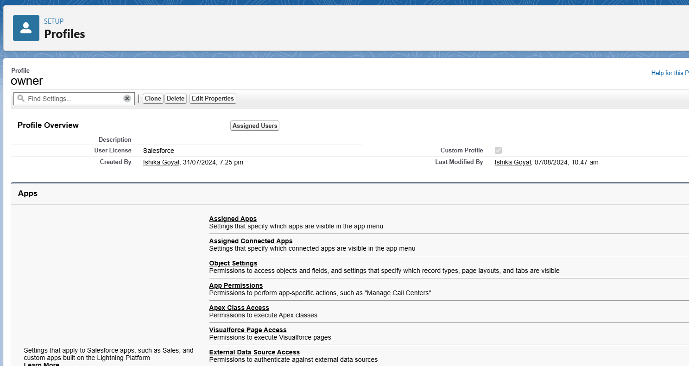

1. Scroll down to Custom Object Permissions and Give access permissions for consumers, rice details , rice mill and suppliers objects as mentioned in the below diagram.

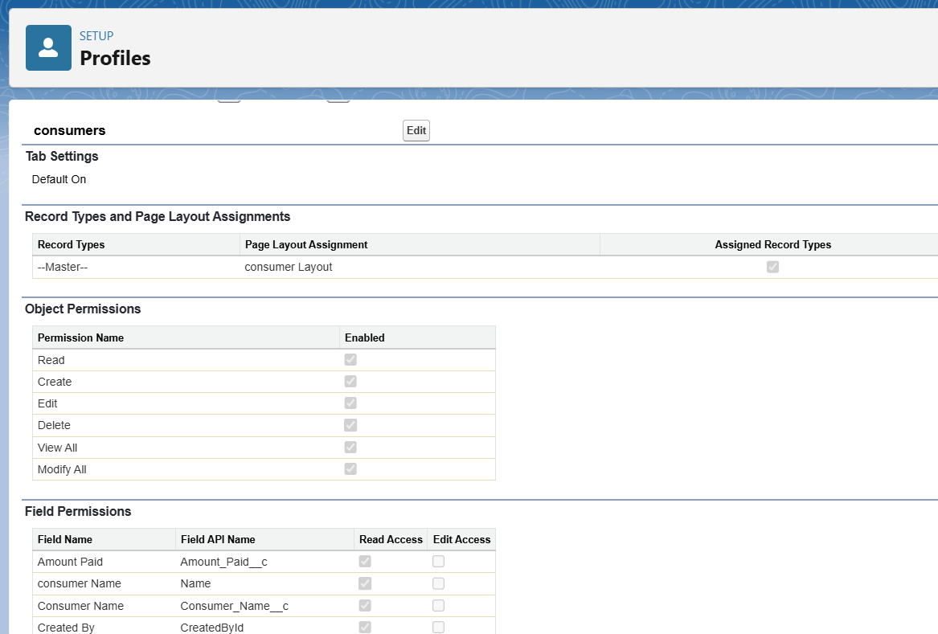

1. Give access and save it.

### **Employer Profile**

1. Go to setup >> type profiles in quick find box >>click on profiles >> clone the desired profile (Standard Platform User) >> enter profile name (employer) >> Save.
2. While still on the profile page, then click Edit.
3. Select the Custom App settings as default for the rice mill.
4. Scroll down to Custom Object Permissions and Give access permissions for consumer, rice details , rice mill and suppliers objects as mentioned in the below diagram.

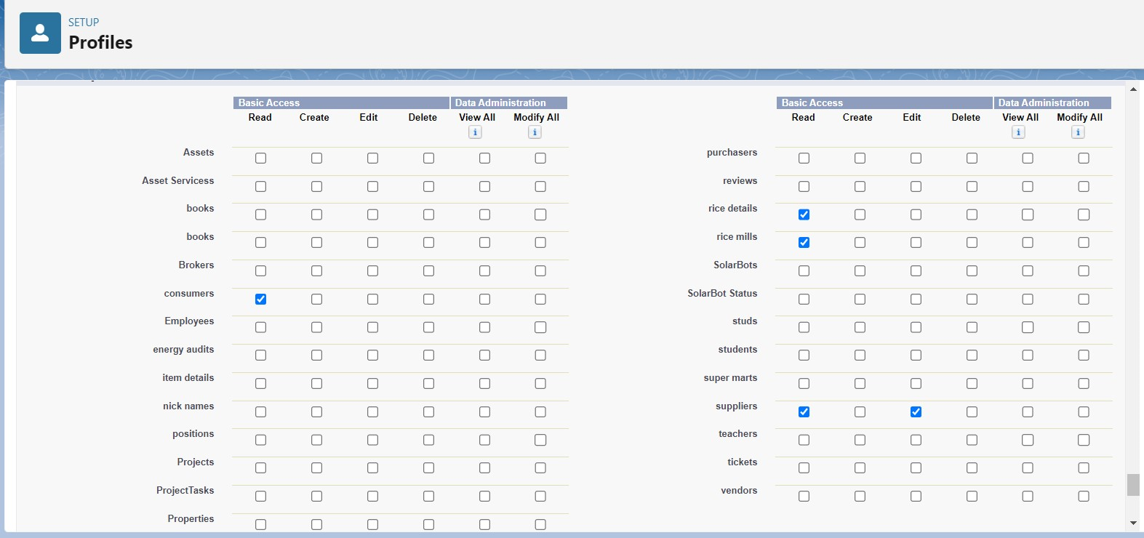

1. And click save.

### 

### **Worker Profile**

1. Go to setup >> type profiles in quick find box >> click on profiles >> clone the desired profile (Standard Platform User) >> enter profile name (worker) >> Save.
2. While still on the profile page, then click Edit.
3. Select the Custom App settings as default for the rice mill.
4. Scroll down to Custom Object Permissions and Give access permissions for consumer, rice details , rice mill and suppliers objects as mentioned in the below diagram.

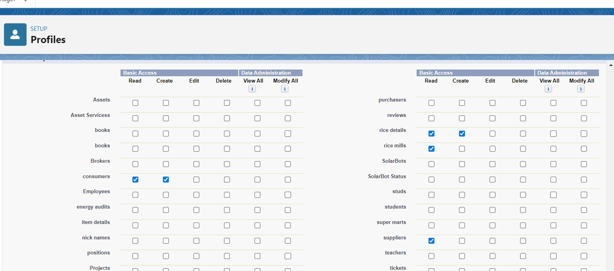

1. And click save.

**Task 8: Creating Roles**

**Creating owner role**

1. Go to quick find >> Search for Roles >> click on set up roles.  
    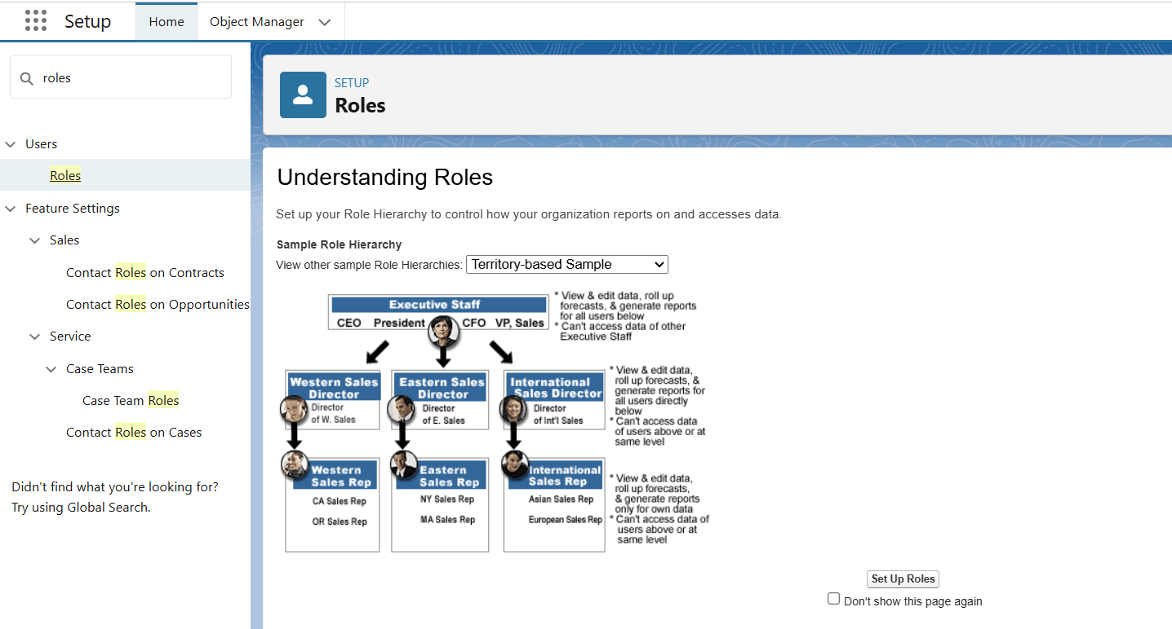
2. Click on Expand All and click on add role under whom this role works.
3. Give Label as “owner” and Role name gets auto populated. Then click on Save.  
     
   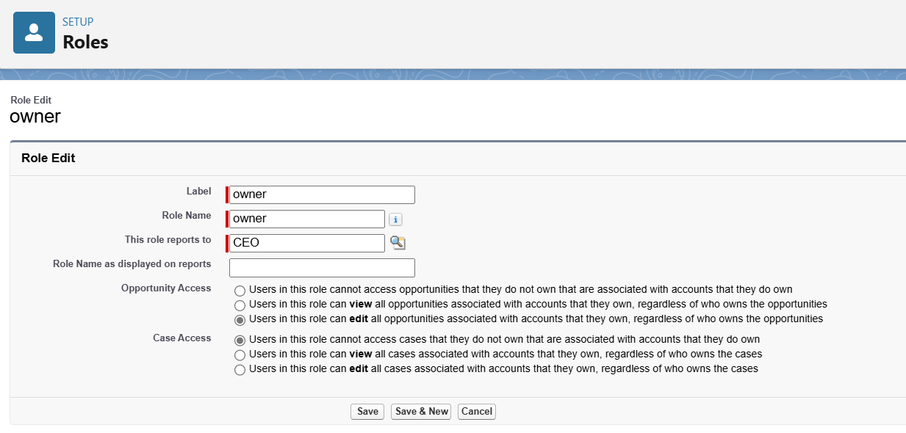
4. Click and save it.

### **Creating employer roles**

Creating another two roles under manager

1. Go to quick find >>Search for Roles >>click on set up roles.
2. Click plus on CEO role, and click add role under owner.
3. Give Label as “employer” and Role name gets auto populated. Then click on Save.

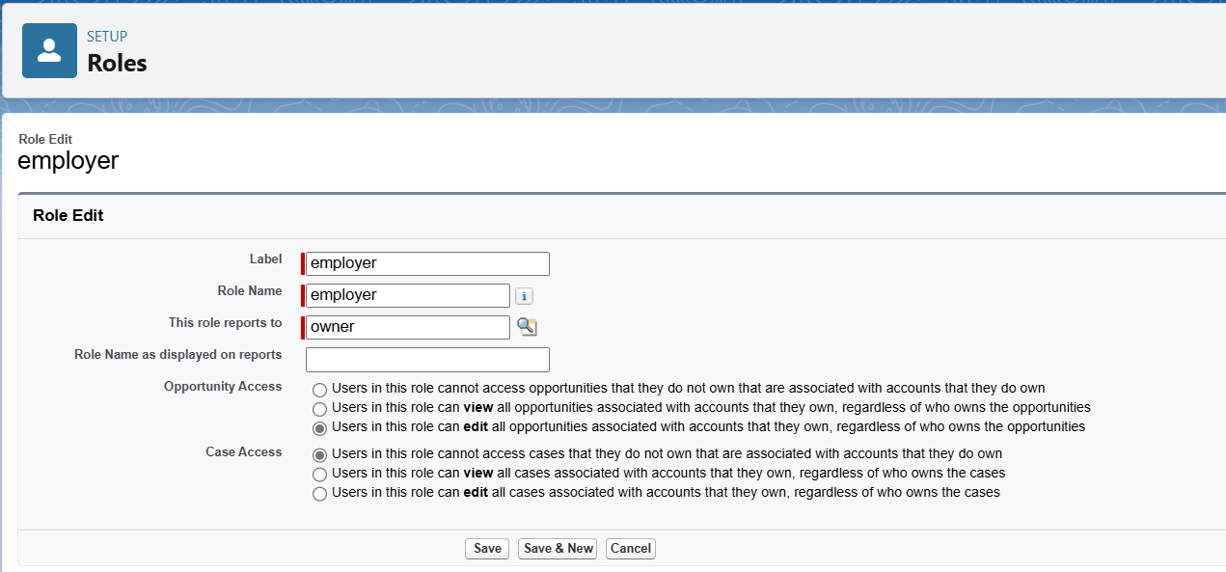

1. Repeat the same steps, for another role.
2. Click plus on CEO role, and click plus on owner, and click add role under employer.
3. give Label as “worker” and Role name gets auto populated. Then click on Save.

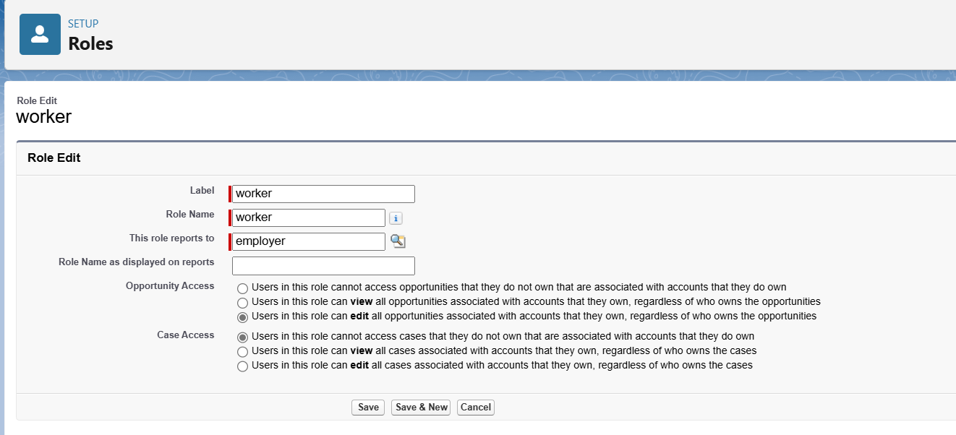

**Task 9: Creating Users**

1. Go to setup >> type users in quick find box >> select users >> click New user.
2. Fill in the fields
3. First Name : vicky
4. Last Name : y
5. Alias : Give a Alias Name
6. Email id : Give your Personal Email id
7. Username : Username should be in this form: text@text.text
8. Nick Name : Give a Nickname
9. Role : owner
10. User license : Salesforce
11. Profiles : owner.  
    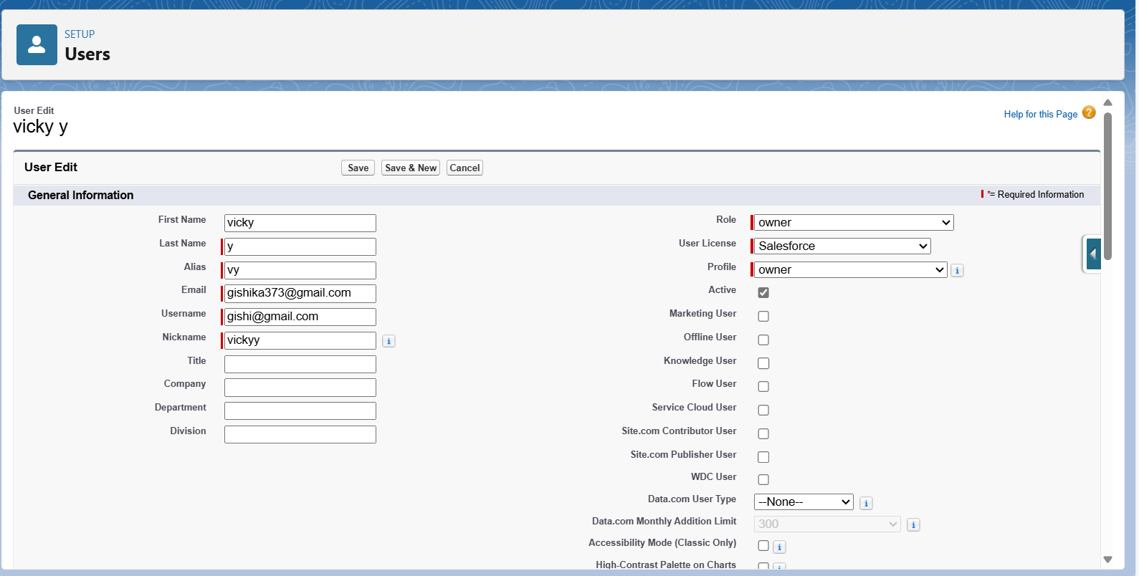
12. Save it.

Similarly, Creating another user –

1. Go to setup >> type users in quick find box >> select users >> click New user.
2. Fill in the fields
3. First Name : ram
4. Last Name : ram
5. Alias : Give a Alias Name
6. Email id : Give your Personal Email id
7. Username : Username should be in this form: text@text.text
8. Nick Name : Give a Nickname
9. Role : employer
10. User license : Salesforce platform
11. Profiles : standard platform user.

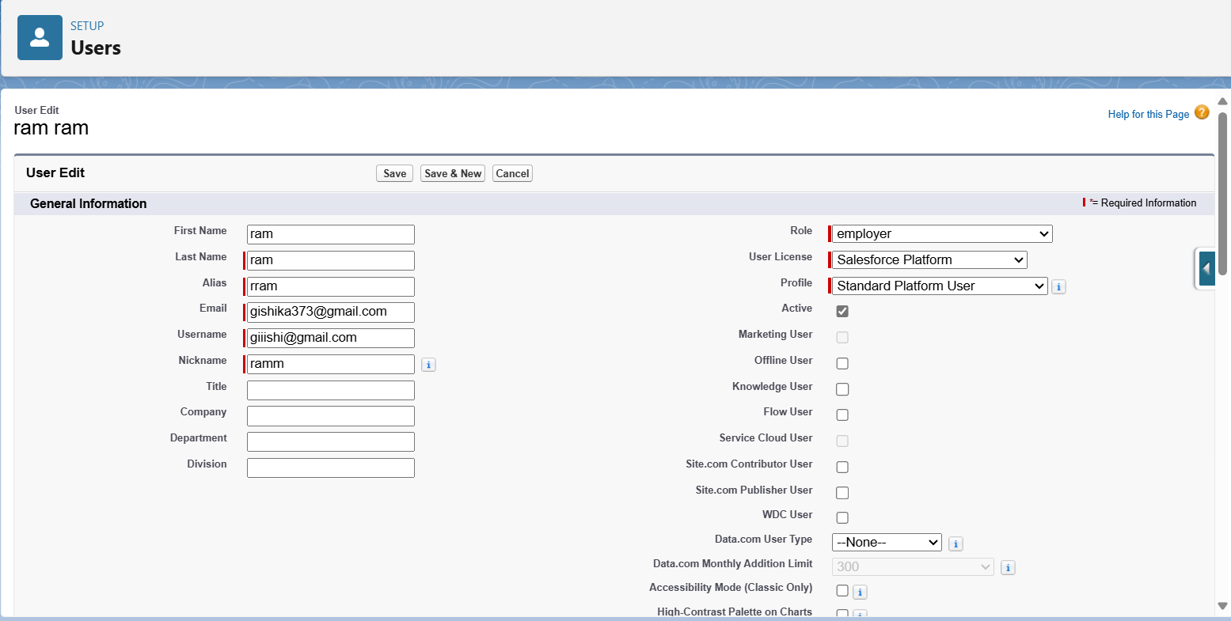

Again, Creating another user –

1. Go to setup ? type users in quick find box ? select users ? click New user.
2. Fill in the fields
3. First Name : ragu
4. Last Name : raj
5. Alias : Give a Alias Name
6. Email id : Give your Personal Email id
7. Username : Username should be in this form: text@text.text
8. Nick Name : Give a Nickname
9. Role : worker
10. User license : Salesforce platform
11. Profiles : standard platform user.

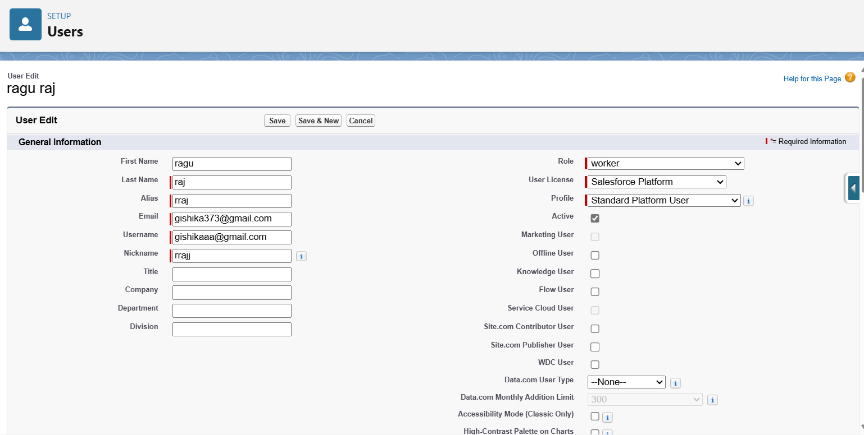

**Task 10: Permission Sets**

### **Creating OWD setting.**

1. Go to setup >> type “sharing settings ” in quick search >> Click edit.  
     
   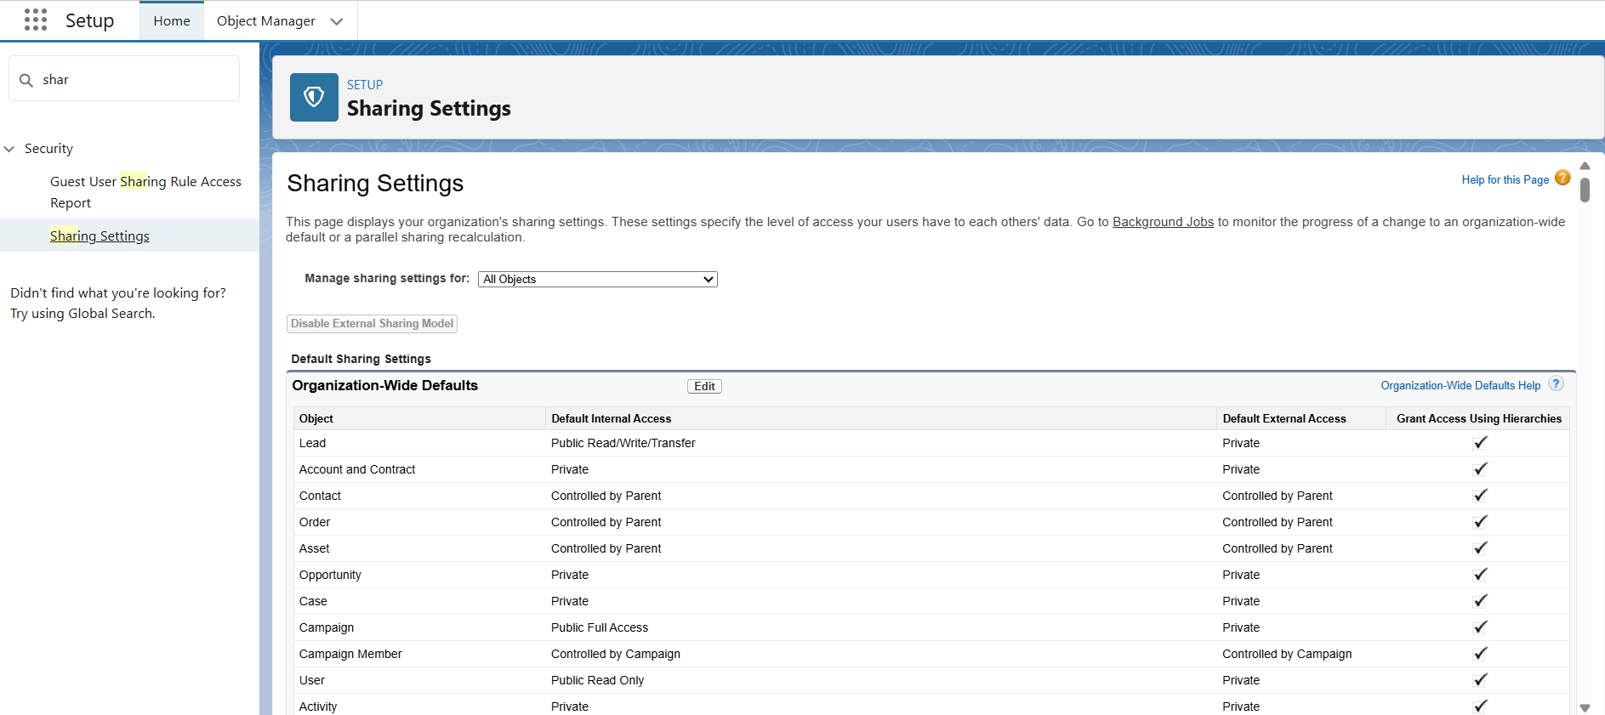
2. Scroll down, change the default internal access to “ public read-only” for rice mill and supplier object.
3. Click save.

**Task 11: Creating Report**

**Before creating a report, create the latest “10” records in consumer objects.**

1. Go to App Launcher >> Consumers >> New.

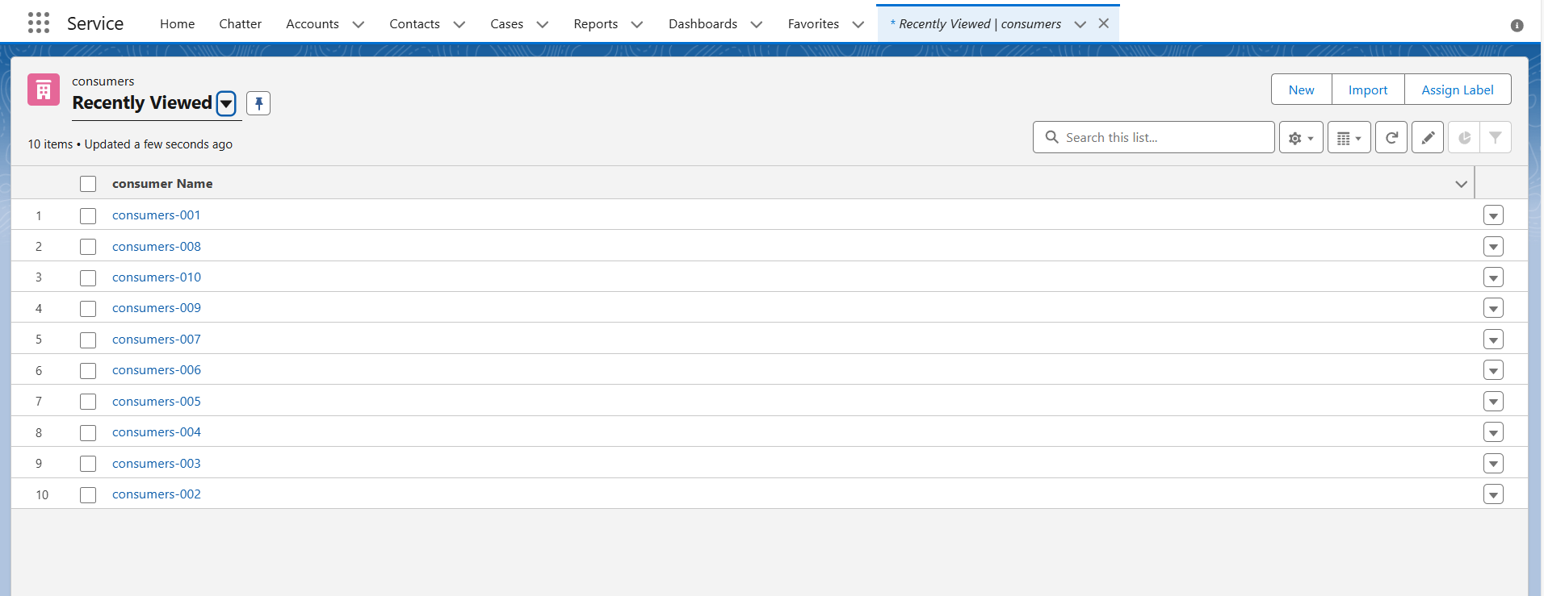

1. Fill all the Details.

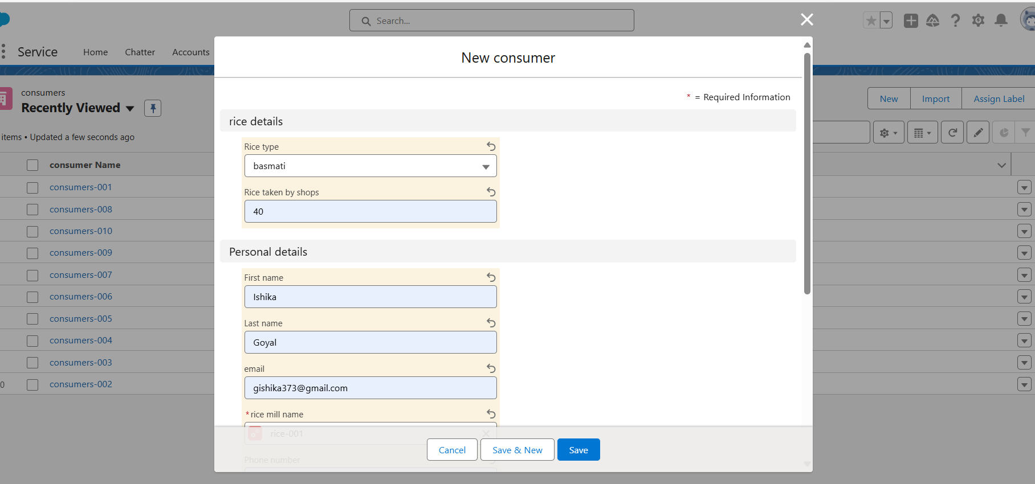

1. Click Save and New.

**Creating a report**

1. Go to the app >> click on the reports tab
2. Click New Report.
3. select for report type, search for “rice mill with consumers” click on it. And click on start report.

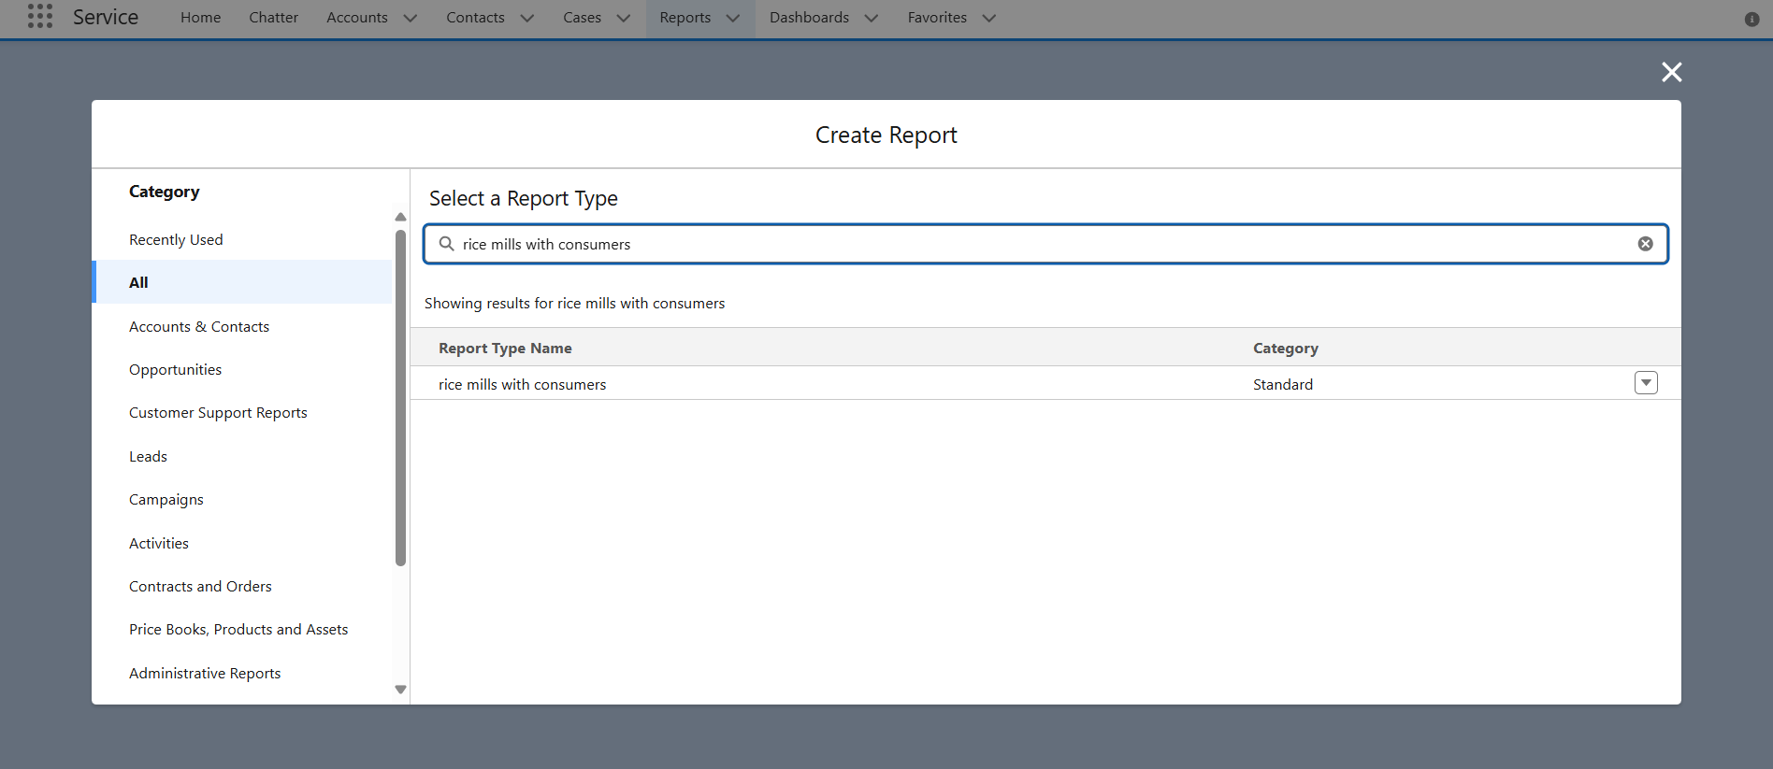

1. Their outline pane is opened already, select the fields that are mentioned below in the column section.

1.consumer name

2.rice type

3.rice price/kg

4.mode of payments

5.amount paid

1. Remove the unnecessary fields.
2. Select the fields that are mentioned below in the GROUP ROWS section.
   1. Rice taken by shops

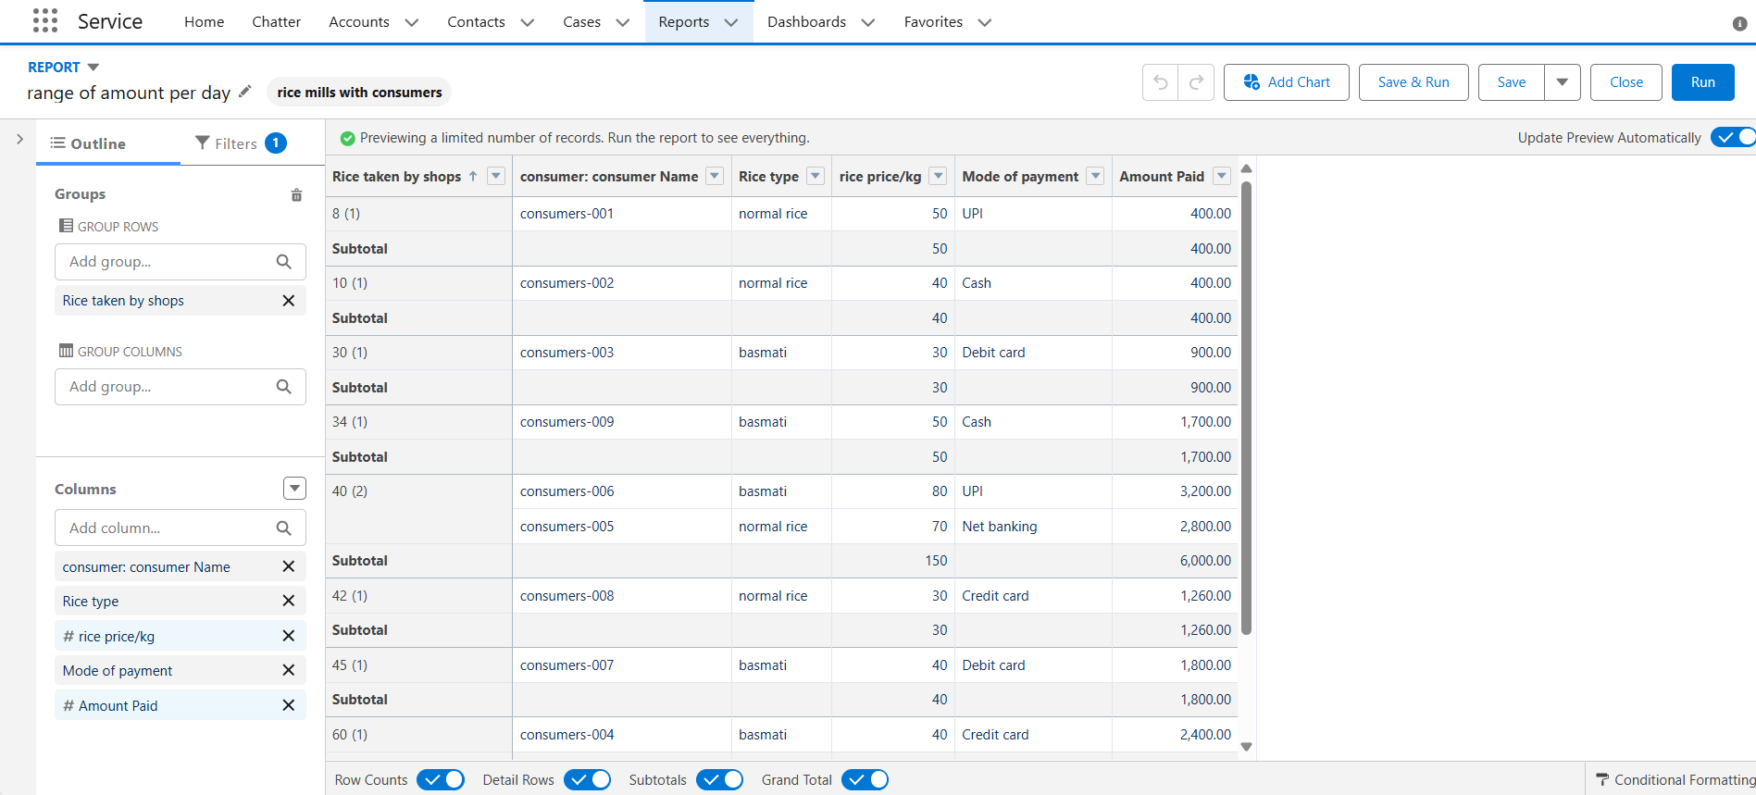

1. Click save and run and save the report as “range of amount per day”.and save it.  
   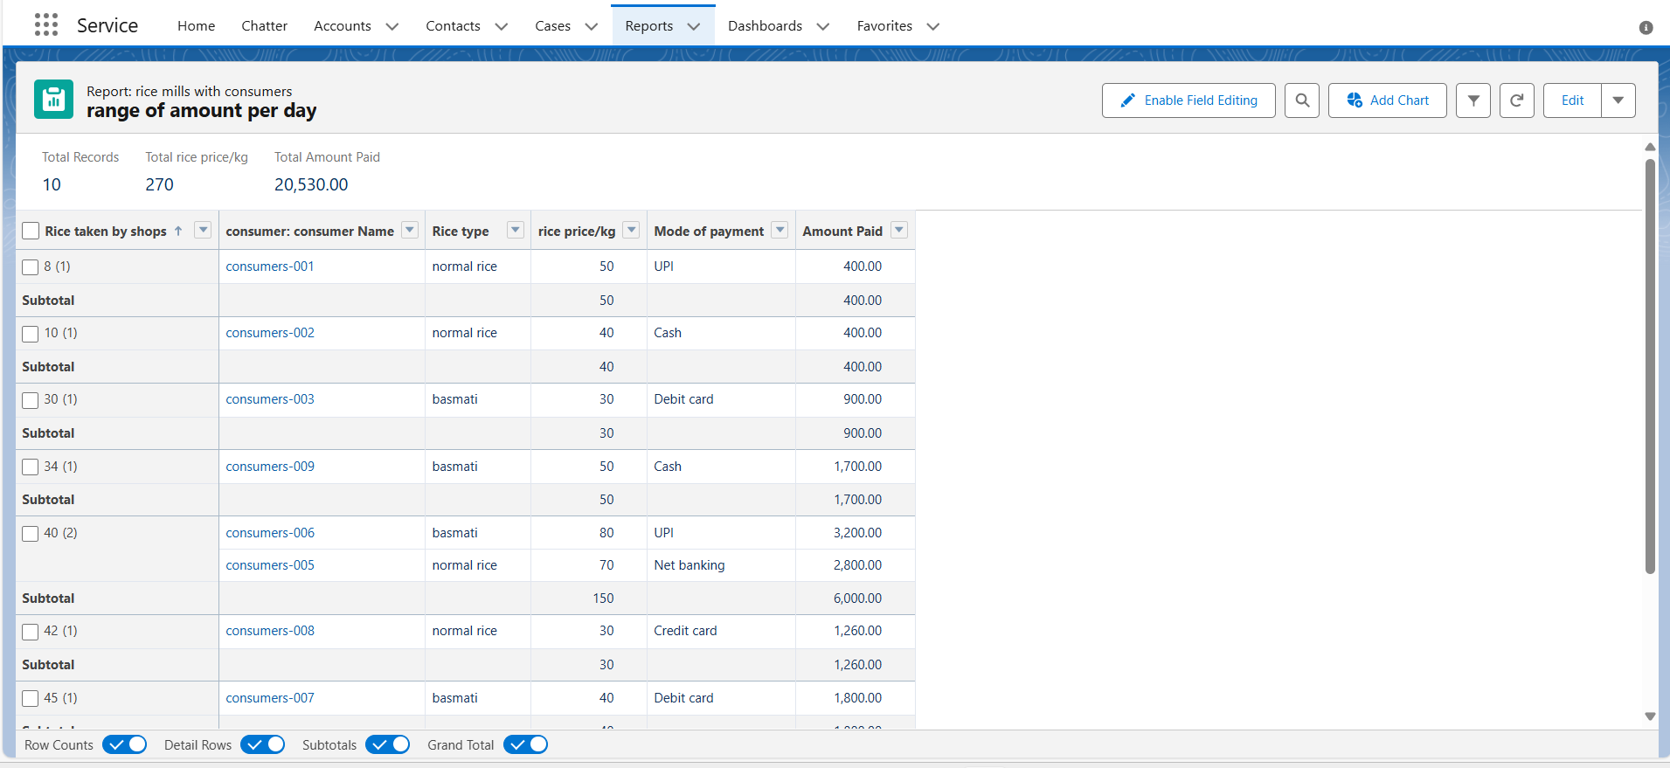

### **Sharing report to owner**

1. Click edit drop down and select subscribe option   
     
   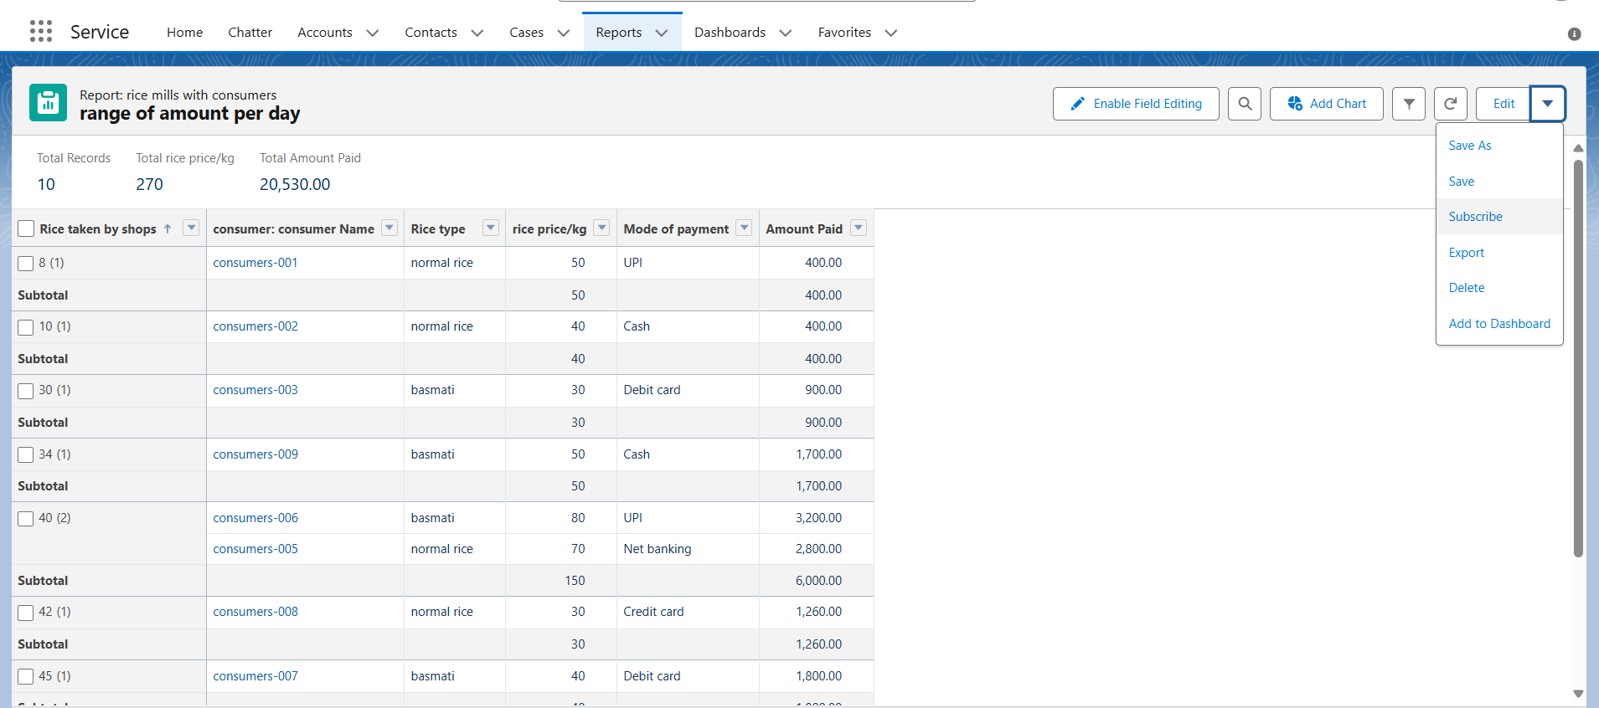
2. Follow as per below image.

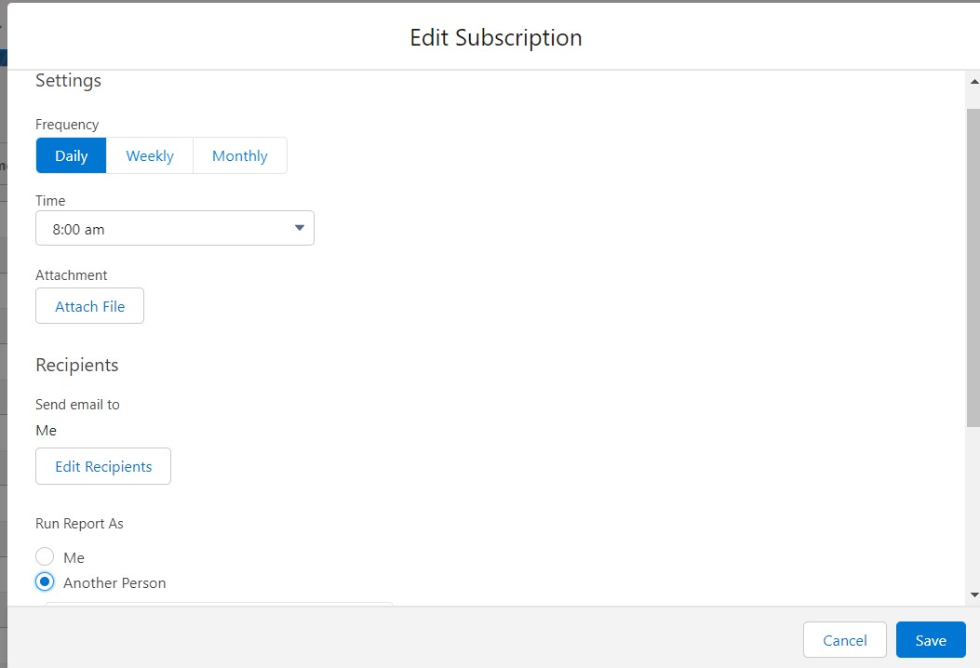

1. After selecting the run report as a “another person” select your personal account or whom you want to send that mail to.
2. Click save.

### **Create a report folder**

1. Click on the app launcher and search for reports.
2. Double click on the report, “ reports tab” will be auto populated in the navigation bar.
3. Click on the report tab, click on the new folder.
4. Give the Folder label as “estimated rice per day ”, Folder unique name will be auto populated.
5. Click save.

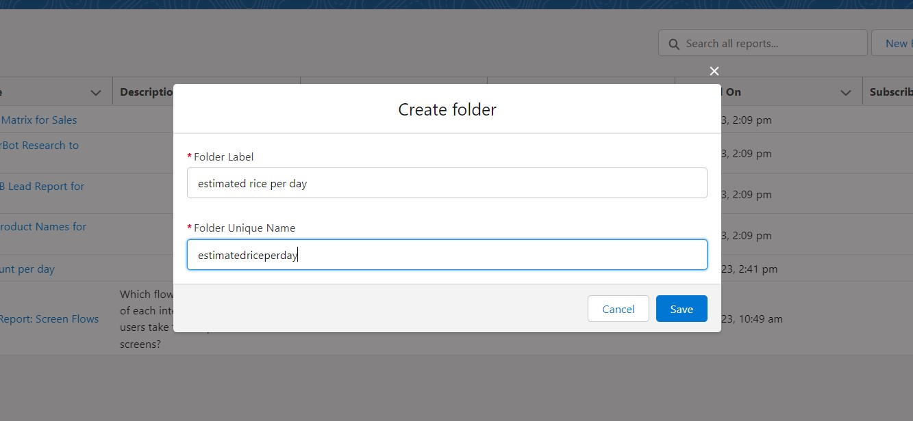

1.navigate to app launcher and click reports on that.

2.click all reports.

3. Select the range of amount per day drop down in that click move.  
  
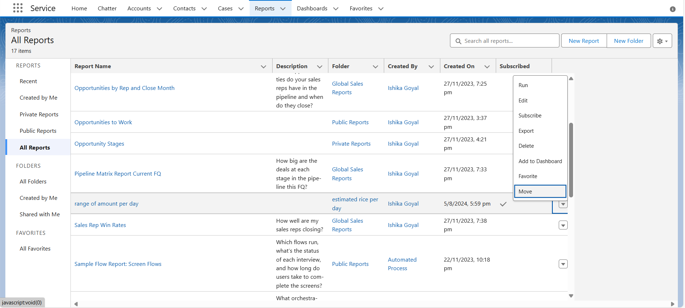

5. Select estimated rice per day folder and select folder.

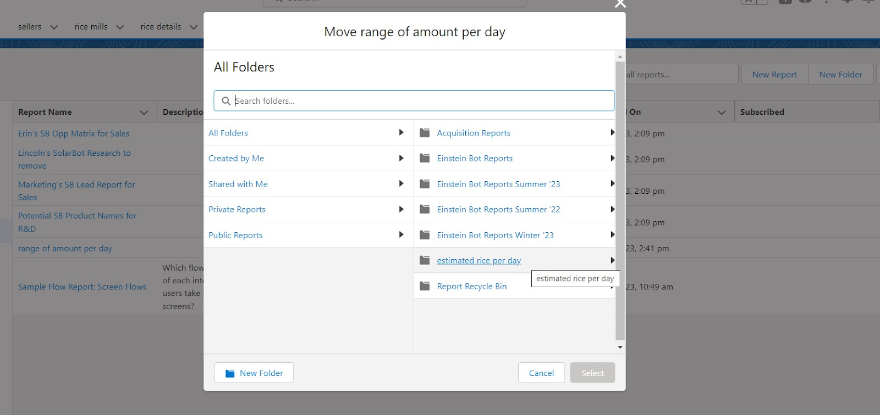

**Task 12: Creating Dashboard**

### **Create Dashboard Folder**

1. Click on the App launcher >> dashboard.
2. Click on the dashboard tab.
3. Click the new folder, give the folder label as “ amount data dashboard”.
4. Folder unique names will be auto populated.
5. Click save.

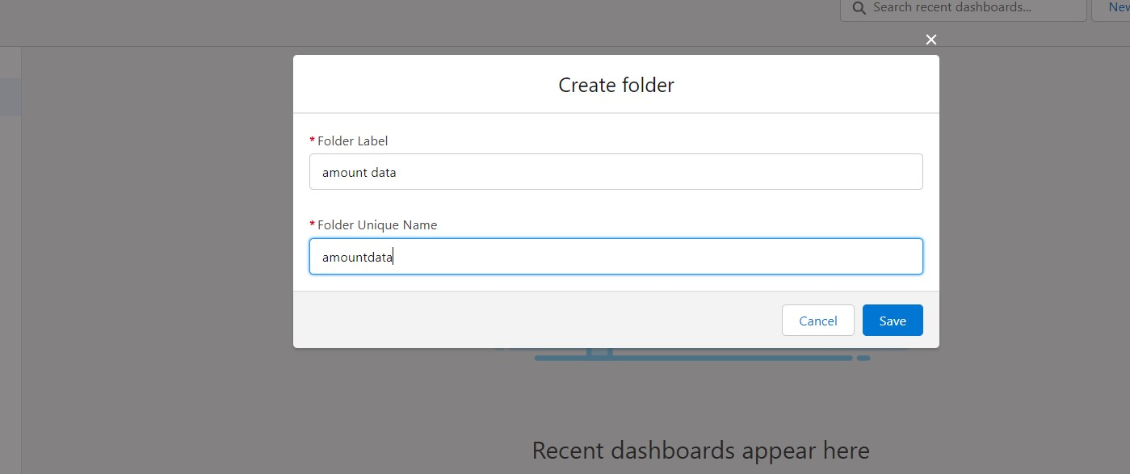

### **Create Dashboard**

1. Go to the app >> click on the Dashboards tabs.
2. Give a Name and select the folder that was created, and click on create.

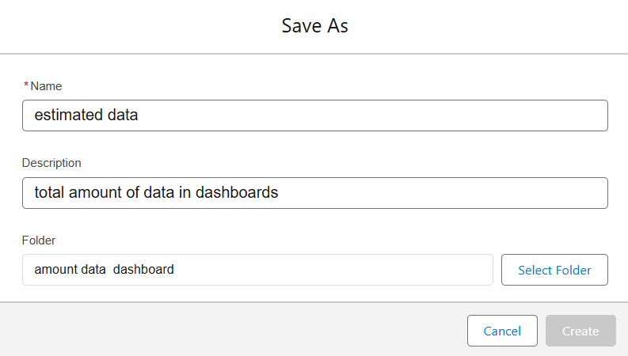

1. Select add component.
2. Select a Report and click on select.
3. Preview is shown below.

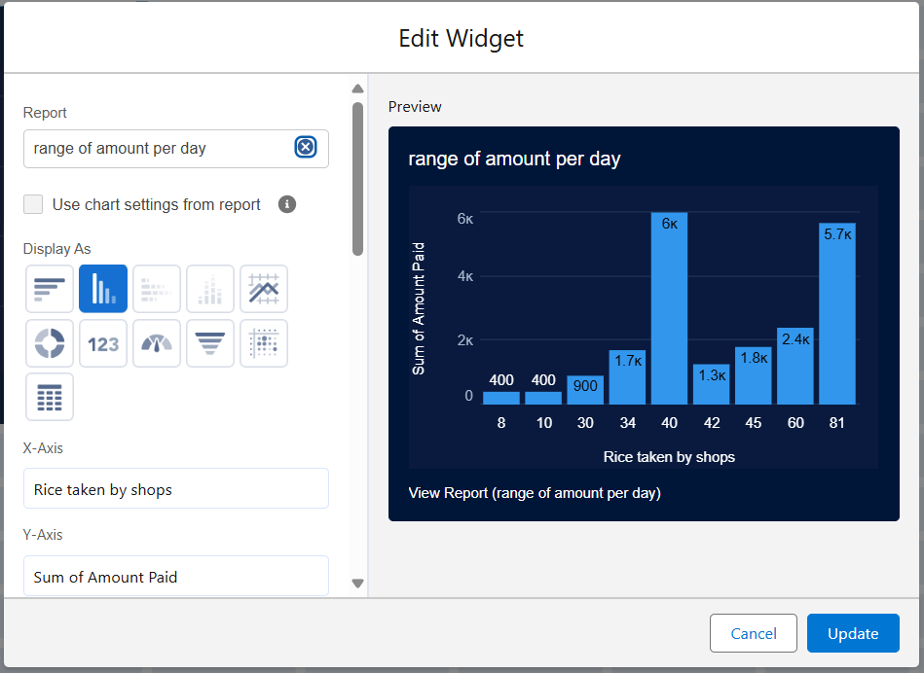

Display as>> vertical bar chart

X-axis >> rice taken by shops

Y-axis >> sum of amount

Y-axis range >> automatic

Sort by >> rice taken by shops

Component theme >> dark.

Add the component,

1. Again select add component with above same steps

1.display as donut chart

2.sort by >> sum of amount

3.title>>range of amount per day

4.component theme dark

Click add.

Click save and done.

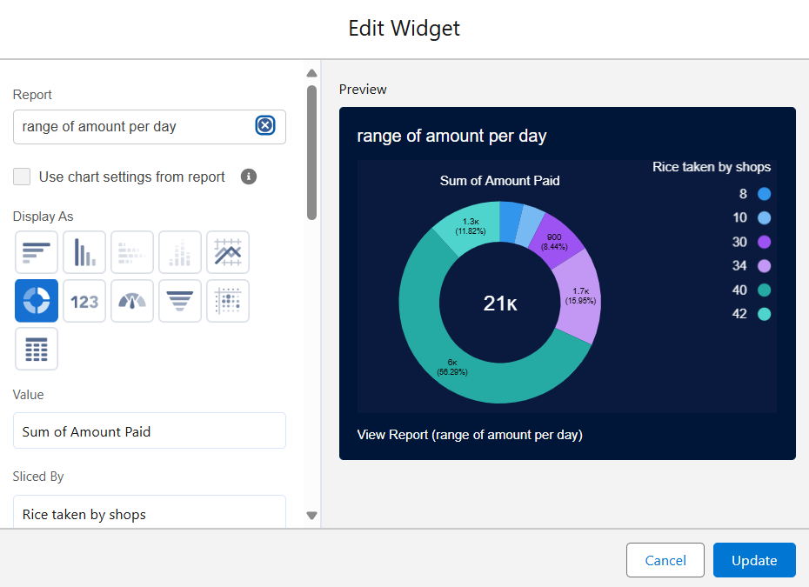

**Task 13: Apex**

### **Creating an Apex Class(ConsumerRecord)**

1. Login to the Salesforce account and navigate to the gear account in the top right corner.
2. Then we can see the Developer console. Click on the developer console and you will navigate to a new console window.
3. Then you can see many tools in the Toolbar of the new console window. Click on File, New and Apex Class.
4. Enter the name of the class(ConsumerRecord) to create a new class file.

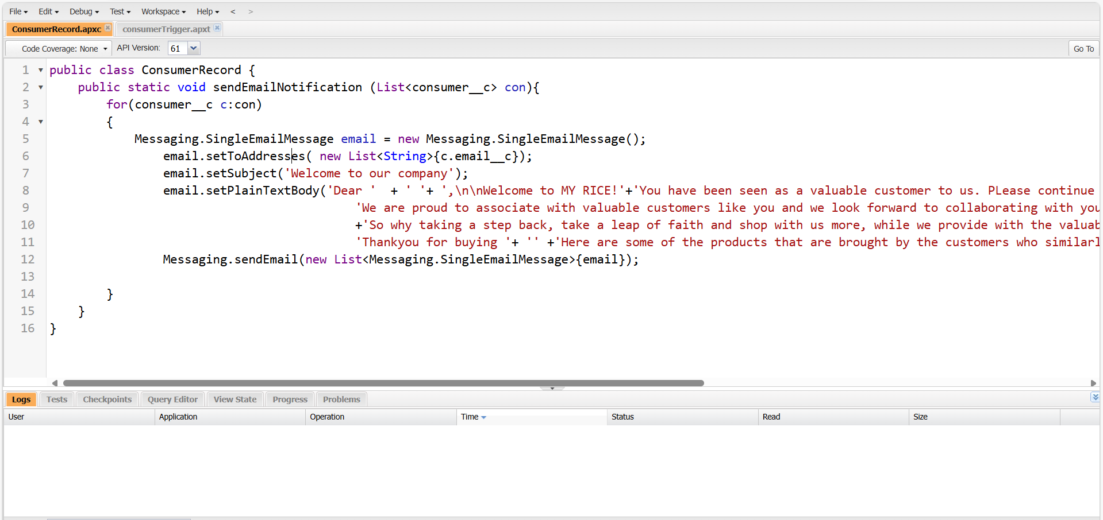

### **Creating an Apex Trigger**

1. Click on developer console and you will be navigated to a new console window.
2. Click on the File menu in the toolbar, and click on new >> Trigger.
3. Enter the trigger name and the object to be triggered.

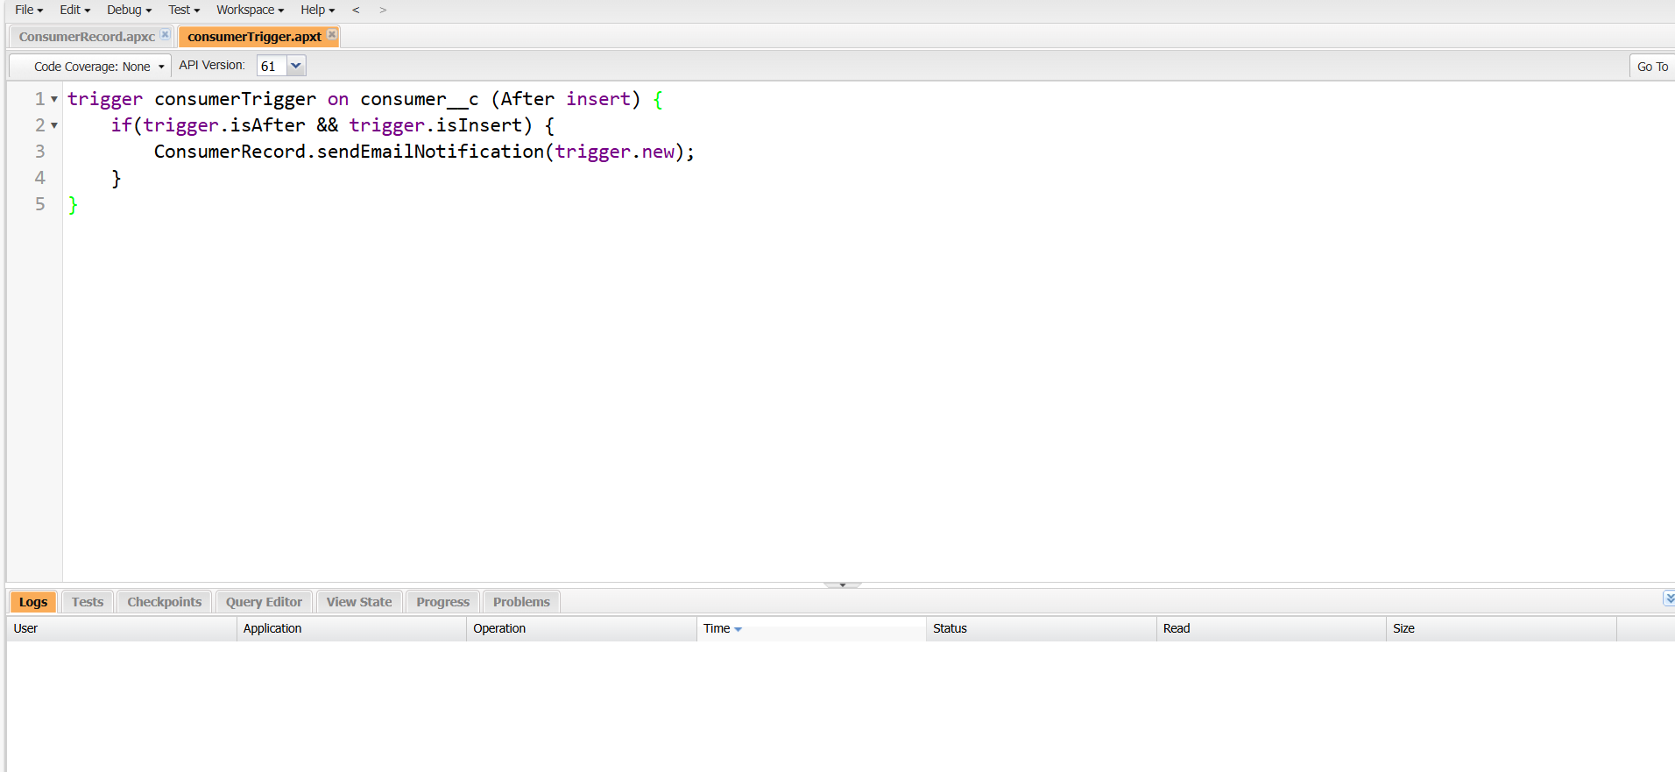

**Thank you**